

 PROJECT REPORT

**ON**

LUNG CANCER PREDICTION SYSTEM

Under The Guidance Of:

Prof. Bibhudendu Panda

# **SUBMITTED**

# **TO**

**ROURKELA INSTITUTE OF MANAGEMENT STUDIES**

# (As a partial fulfilment of the requirement for the award of Degree)

# **FOR**

**MASTER IN COMPUTER APPLICATION**

**SUBMITED BY**

**PRIYANKA PATEL**

# **REGD NO: 2105260013**

# **MCA 4TH SEMESTER (2021-2023)**

**ROURKELA INSTITUTE OF MANAGEMENT STUDIES**

(Affiliated to Biju Patnaik University of Technology)

**Rourkela,Odisha**



**Rourkela Institute of Management Studies**

Rourkela

Department of Computer Science

Rourkela Institute of Management Studies

Chhend, Rourkela-15, Odisha

Visit: https://rimsedu.ac.in/

# **CERTIFICATE OF EXAMINATON**

This is to certify that this project report entitled “LUNG CANCER PREDICTION SYSTEM”, was completed under the Guidance Of Prof. Bibhudendu Panda, by PRIYANKA PATEL of 4th semester, Rourkela Institute of Management Studies, Rourkela, is accepted as partial fulfillment of requirements for the degree in Master in Computer Applications, under Biju Patnaik University of Technology, Rourkela . This has been verified by us and found to be original .

# **Examiner**



**Rourkela Institute of Management Studies**

Rourkela

Department of Computer Science

Rourkela Institute of Management Studies

Chhend, Rourkela-15, Odisha

Visit: https://rimsedu.ac.in/

# **CERTIFICATE OF EXAMINATON**

This is to certify that this project report entitled “LUNG CANCER PREDICTION SYSTEM”, was completed under the Guidance Of Prof. Bibhudendu Panda, by PRIYANKA PATEL of 4th semester, Rourkela Institute of Management Studies, Rourkela, is accepted as partial fulfillment of requirements for the degree in Master in Computer Applications, under Biju Patnaik University of Technology, Rourkela . This has been verified by us and found to be original .

**Examiner**



**Rourkela Institute of Management Studies**

Rourkela

Department of Computer Science

Rourkela Institute of Management Studies

Chhend, Rourkela-15, Odisha

Visit: https://rimsedu.ac.in/

# **CERTIFICATE**

This is to certify that this project entitled **“LUNG CANCER PREDICTION SYSTEM” was completed u**nder **t**he Guidance OfProf. Bibhudendu Panda,has been submitted by **PRIYANKA PATEL,** M.C.A 2021-2023, **Rourkela Institute of Management Studies, Rourkela,** has been examined by us.

She is found fit and approved for the award of **“Master in Computer Application “**Degree.

To the best my knowledge this work has not been submitted for the award of any other degree.

I wish all success in her life.

**DEAN ACADEMIC**

**RIMS, ROURKELA**



Prof. Bibhudendu Panda

Head of The Department, MCA

Rourkela Institute of Management Studies Rourkela

# **CERTIFICATE**

This is to certify that **PRIYANKA PATEL** student of **M.C.A, Rourkela Institute of Management Studies, Rourkela, Odisha** of Session 2021-2023 has completed the project successfully at Department of Computer Science **“RIMS”,Rourkela.**

I wish all success in her life

# **(Prof. Bibhudendu Panda)**



**DECLARATION**

I **PRIYANKA PATEL**, hereby declare that the project report entitled “**LUNG CANCER PREDICTION SYSTEM**” **was completed u**nder **t**he Guidance OfProf. Bibhudendu Panda, is of my work. The above work I submitted to “**Biju Patnaik University of Technology, Rourkela”** for the award of **“Master in Computer Applications**” Degree.

To the best of my knowledge, this work has not been submitted or published anywhere for the award of any degree.

# **PRIYANKA PATEL**

# **REGD NO: 2105260013**

**MCA 4TH SEMESTER (2021-2023)**



**ACKNOWLGEMENT**

I would like to express my gratitude to **Mr. Pritam Patel** for his guidance and support during the project work.

I am deeply indebted to **Rourkela Institute of Management Studies, Chhend, Rourkela,** for providing me an opportunity to undertake a project work entitled **“LUNG CANCER PREDICTION SYSTEM”.**

I am grateful to my project guide **Prof. Bibhudendu Panda** without his guidance it would not have been possible on my part to complete the project.

I acknowledge the help and co-operation received from all my team members in making this project.

I consider myself fortunate that I have successfully completed this project; I acknowledge my sincere gratitude to all those works and ideas that had helped me in writing this project.

#### **PRIYANKA PATEL**

**University Roll No: 2105260013**

**MCA (2021-2023)**

**Rourkela Institute of Management Studies ,Rourkela.**

## ABSTRACT

This project presents a Lung Cancer Prediction System (LCPS) that utilizes machine learning algorithms to predict the likelihood of lung cancer in patients. Early detection is crucial for improving patient outcomes and survival rates. The system leverages a diverse dataset, encompassing patient demographics, medical history, genetic markers, lifestyle factors, and CT scan images. After careful data preprocessing and feature engineering, three machine learning algorithms - Support Vector Machines, Random Forest, and Convolutional Neural Networks - are evaluated and compared. The LCPS is implemented as a user-friendly web application, enabling medical professionals to input patient information and receive rapid risk scores and risk category classifications. Performance evaluation on an independent test dataset demonstrates promising results with high accuracy, sensitivity, and specificity. The system holds significant potential to aid healthcare professionals in early lung cancer detection, potentially saving lives and reducing the burden of this devastating disease.

## CONTRIBUTION OF INDIVIDUAL TEAM MEMBERS

|  |  |  |
| --- | --- | --- |
| **Name of the Student(s)** | **Registration Number** | **Contributions** |
| Priyanka Patel | **2105260013** | Frontend Design and Team Lead |
| Ankita Purohit | **2105260003** | Backend Implementation and UI Integration |
| Priyanka Priyadarshini Pati | **2105260014** | ML Model Design and ML Algorithm Implementation |
| S.Manish Nair | **2105260017** | Database Design and Connectivity |

## GANTT CHART

## 

**Table of Content:**

**INDEX Page No**

### Chapter 1. Introduction ------------------------------------------------------- 2-44

1. Introduction to the System
2. Problem Definition
3. Aim
4. Objective
5. Goal
6. Need of System
7. Litereture Survey
8. Project Planning
9. Environment Setting

### Chapter 2. Hardware and Software requirement------------------------45-46

1. Introduction
2. System environment
3. Software requirement
4. Hardware requirements

### Chapter 3. System Analysis -----------------------------------------------47-49

1. Purpose
2. Project Scope
3. Existing System
4. Proposed System
5. System Description

### [Chapter 4.Implementation issues](#chap 8) --------------------------------------50-51

### 

1. Python
2. HTML
3. Cascading style sheet(CSS)
4. Sqlite

Chapter 5. System Design -----------------------------------------------52-60

1. Introduction
2. Conceptual Design

3) ER-Diagram

1. Logical Design
2. Physical Design
3. Data Flow Diagram of **“Lung Cancer Prediction System”**

[Chapter 6.User Screens](#chap 8) ---------------------------------------------------61-75

.1)User Screens

### [Chapter 7.Coding](#chap 8) & Testing ---------------------------------------------76-111

1)Coding

2)Testing

[Chapter 8. Conclusion-------------------------------------------------112-115](#chap 9)

1) Features of “**Lung Cancer Prediction System**”

2) Benefits Accrued from “**Lung Cancer Prediction System**”

3)Limitations of “**Lung Cancer Prediction System**”

4)Bibliography

## CHAPTER-1

**INTRODUCTION**

*Contents:*

* Introduction
* Problem Definition
* Aim
* Objective
* Goal
* Need of System

## 

**Introduction to the System:**

Lung Cancer Prediction System using EfficientNet is a deep learning project that aims to predict the presence of lung cancer based on chest X-ray images. It is built using Python Django web framework and utilizes an SQLite database. The system has three main modules - user, admin, and doctor.

The user module includes features such as sign up, login, prediction, view prediction history, and a list of doctors available based on the user's location. After the prediction, if the user is diagnosed with a disease, doctors in the same city will be recommended to the user. The user can also edit their profile, change their password, and logout.

The admin module includes login, a dashboard to view user and prediction results counts, view prediction history, registered users, registered doctors, change password, and logout.

The doctor module includes login, view prediction history of patients from the same city, edit profile, change password, and logout. This feature helps doctors to get patient information for lead generation.

**Problem Definition:**

The problem that the Lung Cancer Prediction System using EfficientNet aims to address is the early detection and prediction of lung cancer. Lung cancer is one of the most common types of cancer, and it is often not detected until it has progressed to an advanced stage, which can limit treatment options and lead to a poorer prognosis. By using deep learning and image analysis techniques, this system seeks to accurately predict the likelihood of a patient having lung cancer based on their medical imaging data, allowing for earlier detection and more effective treatment options.

**Aim:**

The aim of the Lung Cancer Prediction System using EfficientNet is to develop an accurate and efficient deep learning model that can predict the likelihood of a patient having lung cancer based on the analysis of chest CT scan images. The system aims to provide a reliable and quick prediction that can help in the early detection of lung cancer, which can lead to more successful treatment outcomes. Additionally, the system aims to provide a user-friendly interface for both users and medical professionals to easily access and interpret the prediction results.

**Objective:**

The main objectives of the Lung Cancer Prediction System using EfficientNet are:

1. To develop an accurate deep learning model for predicting the presence of lung cancer in patients based on CT scan images.
2. To provide an easy-to-use web application for users to input their CT scan images and receive a prediction of the likelihood of lung cancer.
3. To create a user-friendly interface for doctors to view patient predictions and medical history in order to assist with diagnosis and treatment decisions.
4. To reduce the time and cost associated with traditional lung cancer diagnosis methods by using an automated, computer-based approach.

**Goal:**

The goal of Lung Cancer Prediction System using EfficientNet is to develop an accurate and efficient deep learning model that can predict the likelihood of a patient having lung cancer based on their medical records and diagnostic reports. The system aims to assist doctors and healthcare professionals in the early detection and diagnosis of lung cancer, thereby improving patient outcomes and reducing mortality rates associated with this disease. The ultimate goal is to provide a reliable and accessible tool for lung cancer prediction that can be used by medical practitioners to provide personalized treatment and care for their patients.

**Need of the System:**

The need for the Lung Cancer Prediction System using EfficientNet can be attributed to the fact that lung cancer is a major health concern worldwide and the early detection of lung cancer can significantly improve the chances of successful treatment. With the increasing availability of medical data, it has become important to develop accurate and efficient methods for the early detection of lung cancer. The Lung Cancer Prediction System using EfficientNet is designed to meet this need by utilizing deep learning techniques to accurately predict the probability of lung cancer in patients based on their medical data. This system has the potential to improve the accuracy of lung cancer diagnosis and provide a better chance for successful treatment.

**LITERETURE SURVEY**

## The main objective of this paper is to find the best model to predict the value of the Lungs Predication System. During the process of considering various techniques and variables that must be taken into account, we found out that techniques like random forest, support vector machine were not exploited fully. In, this paper we are going to present and review a more feasible method to predict the stock movement with higher accuracy. The first thing we have taken into account is the dataset of the stock market prices from previous year. The dataset was pre-processed and tuned up for real analysis. Hence, our paper will also focus on data preprocessing of the raw dataset. Secondly, after preprocessing the data, we will review the use of random forest, support vector machine on the dataset and the outcomes it generates.

## Advantages of Paper

## We are able to train the machine from the various data points from the past to make a future prediction.

## The basic approach of the supervised learning model is to learn the patterns and relationships in the data from the training set and then reproduce them for the test data.

## The tuned-up data frame allowed us to prepare the data for feature extraction.

## Disadvantages of Paper

## The existing system fails when there are rare outcomes or predictors, as the algorithm is based on bootstrap sampling.

## The existence system reported highly predictive values, by selecting an appropriate time period for their experiment to obtain highly predictive scores.

## How to overcome the problems mentioned in Paper

## The input datasets will first be processed through the basic algorithms and the outputs from theses algorithms will be feeded to the metal earner.

## The meta-learner will perform the task of optimizing the outputs of the algorithms.

## It itself is another more powerful algorithm which will improve the overall efficiency of the system.

## The meta-learner upon analyzing all the outputs will produce the final prediction for the consumer.

## Technical Review

## learning tools represent key enablers for empowering material scientists and Engineers to accelerate the development of novel materials, processes and techniques. One of the aims of using such approaches in the field of materials science is to achieve high-throughput identification and quantification of essential features along the process-structure-property-performance chain. In this contribution, machine learning and statistical learning approaches are reviewed in terms of their successful application to specific problems in the field of continuum materials mechanics. They are categorized with respect to their type of task designated to be either descriptive, predictive or prescriptive; thus, to ultimately achieve identification, prediction or even optimization of essential characteristics. The respective choice of the most appropriate machine learning approach highly depends on the specific use-case, type of material, kind of data involved, spatial and temporal scales, formats, and desired knowledge gain as well as affordable computational costs.

## Advantages of Technology

## Machine Learning can review large volumes of data and discover specific trends and patterns that would not be apparent to humans.

## With ML, you don’t need to babysit your project every step of the way. Since it means giving machines the ability to learn, it lets them make predictions and also improve the algorithms on their own.

## Reasons to use this Technology

## To identify important insights in data, and prevent fraud.

## Finding new energy sources. Analyzing minerals in the ground. Predicting re- finery sensor failure. Streamlining oil distribution to make it more efficient and cost-effective.

**PROJECT PLANNING**

## Members and Capabilities

Table of Capabilities

|  |  |  |
| --- | --- | --- |
| **Name of the Student(s)** | **Registration Number** | **Capabilities** |
| Priyanka Patel | **2105260013** | Frontend Design |
| Ankita Purohit | **2105260003** | Backend Implementation and UI Integration |
| Priyanka Priyadarshini Pati | **2105260014** | ML Model Design and ML Algorithm Implementation |
| S.Manish Nair | **2105260017** | Database Design and Connectivity |

## Work Breakdown Structure

## All of the members are equally important in developing the project.

## We work on a different part of the project based on one’s capability

## Firstly, we came up with documentation, and based on the documentation we set our goal and created a blueprint.

## We then started going hands-on with the project to develop it according to the flow as decided earlier

## Roles and Responsibilities

|  |  |  |
| --- | --- | --- |
| **Name of the Student(s)** | **Registration Number** | **Responsibilities** |
| Priyanka Patel | **2105260013** | Frontend Design and Team Lead |
| Ankita Purohit | **2105260003** | Backend Implementation and UI Integration |
| Priyanka Priyadarshini Pati | **2105260014** | ML Model Design and ML Algorithm Implementation |
| S.Manish Nair | **2105260017** | Database Design and Connectivity |

## Table :Table of Responsibilities

## Assumptions and Constraints

## Stock analysis is a process followed by traders to evaluate and understand the value of a security or the stock market.

## Stock analysis follows the idea that analysts can create methodologies to select stocks by studying past and present data.

## Generally, predictions of stocks help stock agents to verify the stock prices.

## User of this software will help him to buy the particular software at their best time.

## Project Management Approach

## Planning of project

## Defining the scope of the project.

## Estimation of time and It’s management.

## Creating Gantt Charts and properly assigning tasks to members

## Reporting the progress of project with the guide

## Ground Rules for the Project

## Properly planning and gathering relevant information is very important.

## Developing a Blueprint of the project and work accordingly.

## All the members should report to the guide whenever required

## Setting up small goals every week.

## Achieving the small goal within that span of time.

## Keeping tracks of the progress towards project.

## Project Budget

## It is moderate project with high end technology.

## Cost of the project is low and efficient.

## Time-consuming as it is on latest technologies.

ENVIRONMENT SETTINGS

#### **Prerequisite**

* + Python 3.10 or above
  + NodeJS v16 or above
  + HTML, CSS, JS
  + Angular 11 and it’s Dependencies:

1. Bootstrap=4.6.0
2. font-awesome=4.7.0
3. jQuery=3.5.1
4. popper.js=1.16.1
5. react-bootstrap=1.4.3
6. rxjs=6.6.0
7. typescript=4.1.2
   * Sqllite
   * Ubuntu 20.04 LTS
   * Docker Desktop
   * Microsoft Visual Studio Code
   * Git Bash and GitHub
   * Python Dependencies:
8. #python==3.8.8
9. absl-py==0.15.0
10. asgiref==3.5.2
11. astunparse==1.6.3
12. backports.zoneinfo==0.2.1
13. cachetools==5.2.0
14. certifi==2022.9.24
15. charset-normalizer==2.1.1
16. contourpy==1.0.5
17. cycler==0.11.0
18. Django==4.1.2
19. efficientnet==1.1.1
20. flatbuffers==1.12
21. fonttools==4.37.4
22. gast==0.3.3
23. google-auth==2.13.0
24. google-auth-oauthlib==0.4.6
25. google-pasta==0.2.0
26. grpcio==1.32.0
27. h5py==2.10.0
28. idna==3.4
29. imageio==2.22.2
30. importlib-metadata==5.0.0
31. joblib==1.2.0
32. Keras-Applications==1.0.8
33. Keras-Preprocessing==1.1.2
34. kiwisolver==1.4.4
35. Markdown==3.4.1
36. MarkupSafe==2.1.1
37. matplotlib==3.6.1
38. networkx==2.8.7
39. numpy==1.20.3
40. oauthlib==3.2.2
41. opencv-contrib-python==4.6.0.66
42. opt-einsum==3.3.0
43. packaging==21.3
44. pandas==1.5.0
45. Pillow==9.2.0
46. protobuf==3.19.0
47. pyasn1==0.4.8
48. pyasn1-modules==0.2.8
49. pyparsing==3.0.9
50. python-dateutil==2.8.2
51. pytz==2022.4
52. PyWavelets==1.4.1
53. requests==2.28.1
54. requests-oauthlib==1.3.1
55. rsa==4.9
56. scikit-image==0.19.3
57. scikit-learn==1.1.2
58. scipy==1.9.2
59. seaborn==0.12.0
60. six==1.15.0
61. sklearn==0.0
62. sqlparse==0.4.3
63. tensorboard==2.10.1
64. tensorboard-data-server==0.6.1
65. tensorboard-plugin-wit==1.8.1
66. tensorflow==2.4.3
67. tensorflow-estimator==2.4.0
68. termcolor==1.1.0
69. threadpoolctl==3.1.0
70. tifffile==2022.10.10
71. typing-extensions==3.7.4.3
72. tzdata==2022.5
73. urllib3==1.26.12
74. Werkzeug==2.2.2
75. wrapt==1.12.1

zipp==3.9.0

* Deployment Platform: Docker Desktop

Developed any Project need a IDLE (Integrated Development Environment), so Developer can easily Create, Run, Compile and Execute Programs.

### **How to Install Visual Studio Code on Windows?**

Firstly, download the Visual Studio Code installer for Windows. Once it is downloaded, run the installer (VSCodeUserSetup-{version}.exe). It will only take a minute.

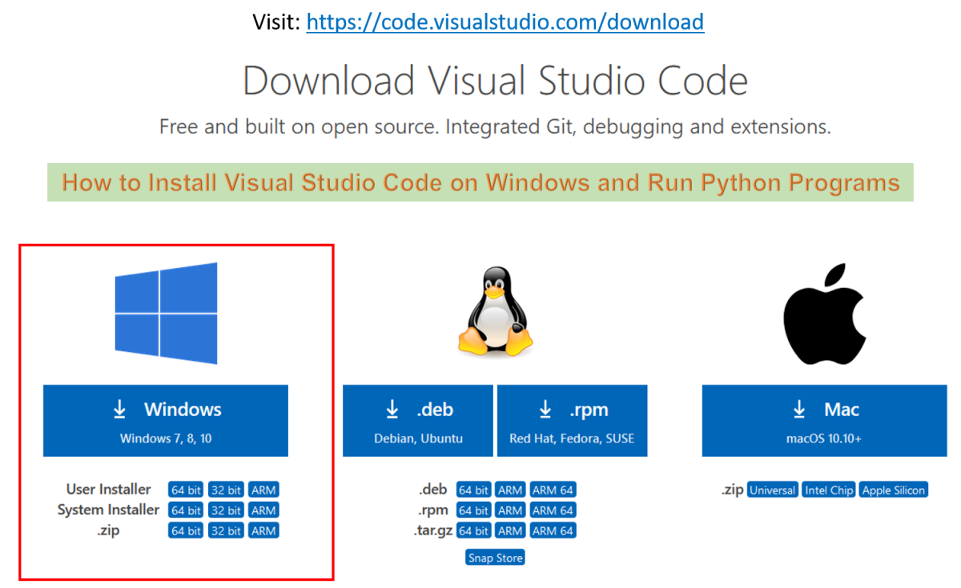

Then double Click on Download folder .exe file and Follow the step by step instruction Process .

Secondly, accept the agreement and click on next.



Thirdly, click on “**create a desktop icon**” so that it can be accessed from desktop and click on Next.

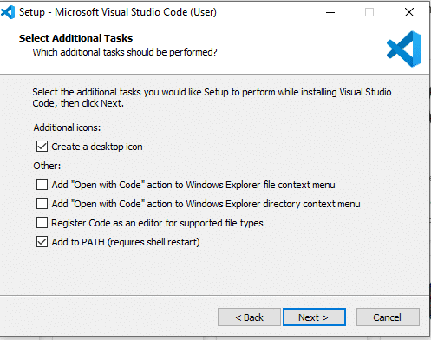

After that, click on the install button.

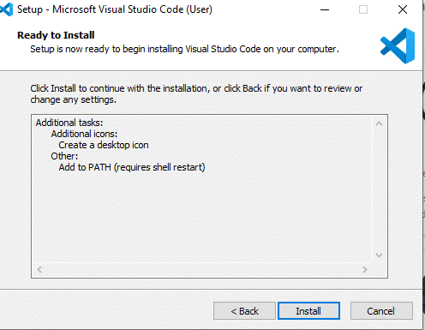

Finally, after installation completes, click on the finish button, and the visual studio code will get open.

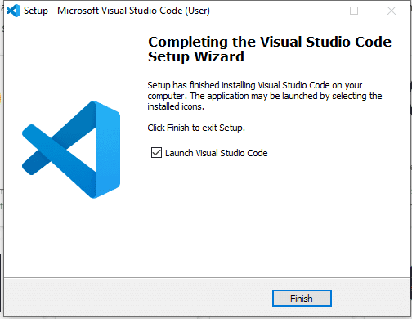

## Steps to Install Python

### Step 1: Download Python 3.9 or Above

To start, go to [python.org/downloads](https://www.python.org/downloads/) and then click on the button to download the latest version of Python:

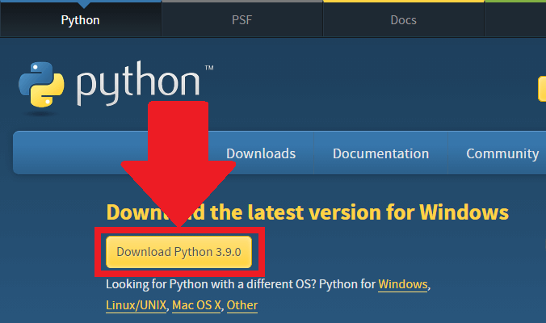

### Step 2: Run the .exe file

Next, run the .exe file that you just downloaded:

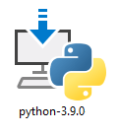

### Step 3: Install Python 3.9

You can now start the installation of Python by clicking on **Install Now**:

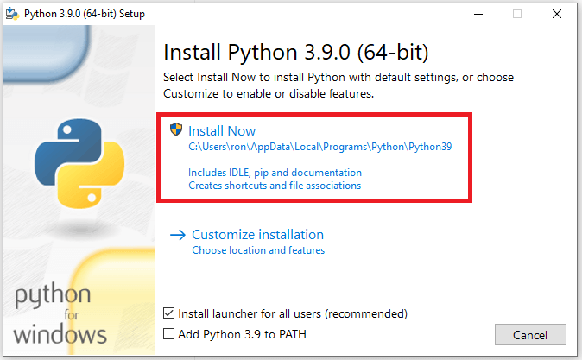

**Important:** You want to be sure to check the box that says **Add Python 3.x to PATH** as shown to ensure that the interpreter will be placed in your execution path.

Your installation should now begin:

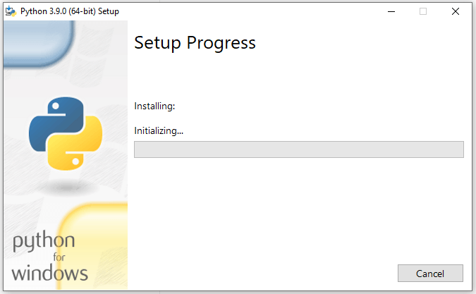

After a short period of time, your setup would be completed:

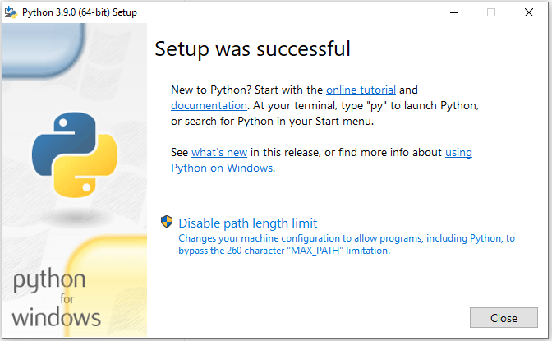

## How to Download and Setup GITBASH

### Step 1: Visit the Official Git Bash

Download the latest version of Git Bash from their official website: <https://git-scm.com/>

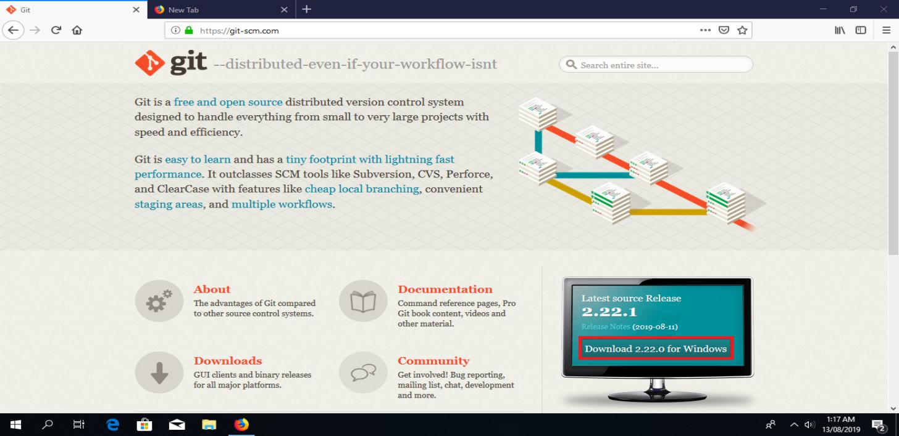

Click the “Download for windows” button.

### Step 2: Start Git Bash Download

Next, you will be redirected to a page that lets you know that you are about to start downloading.

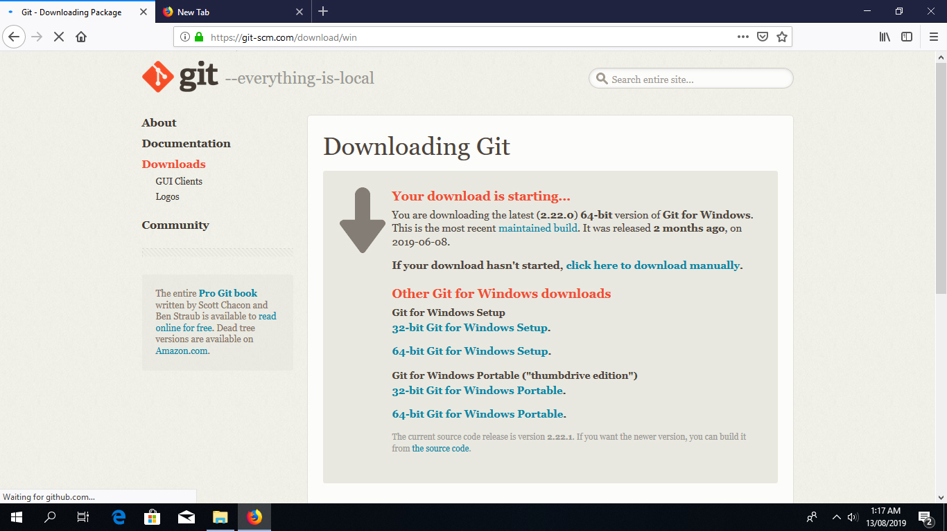

If all goes well, the download should start automatically.

**Tip:** If the download doesn’t start, click on the “click here to download manually” link.

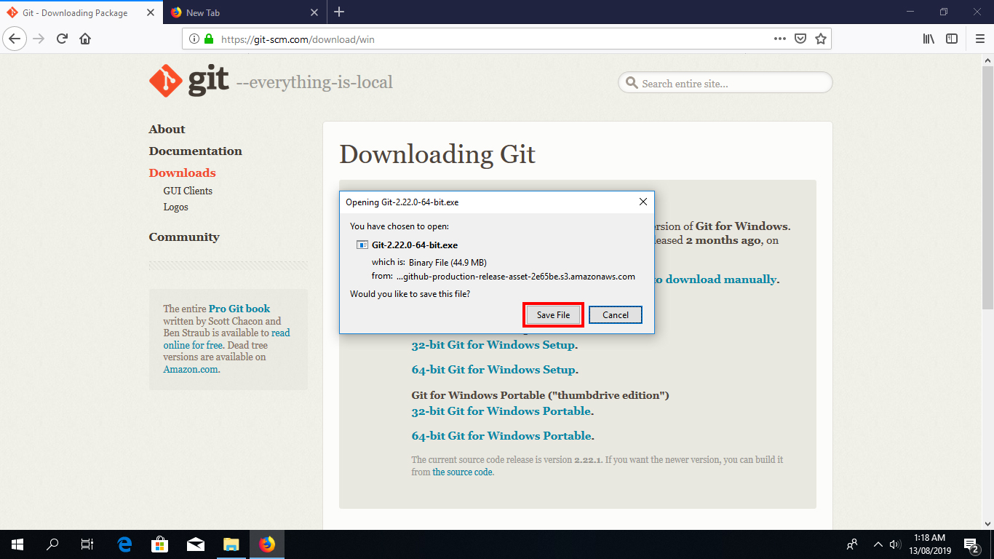

Click on “Save File” to start downloading the executable.

**Install Git Bash**

Step 3: Run the Installer

### Once you have downloaded the Git Bash executable, click it to run the installer.

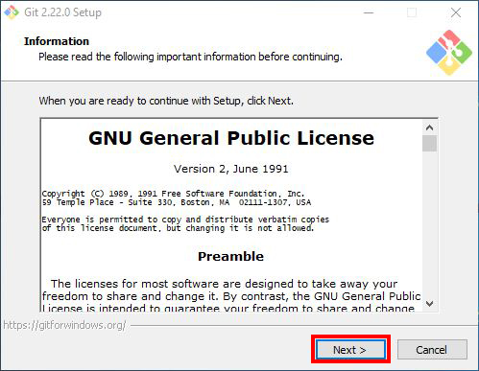

Click “Next” after you have read the license.

### Step 4: Select Destination Location Permalink

Next, select the location you want to install Git Bash. I would recommend you just leave the default option as it is, and click “Next”.

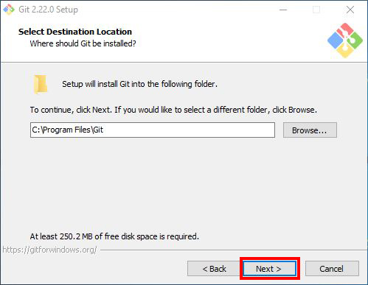

### Step 5: Select Components

Choose the components you want to install, or you can just proceed with the default options and click “Next”. I prefer selecting the “Additional icons” component which creates a Git Bash shortcut on the desktop.

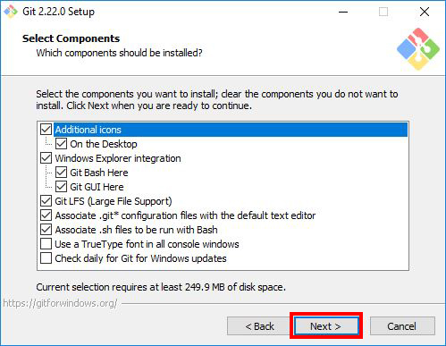

### Step 6: Select Start Menu Folder

You can change the name of start menu folder here if you want, or just leave the default name and click “Next”.

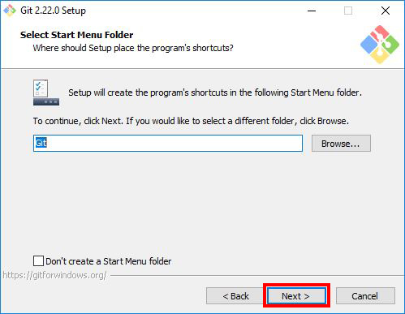

### Step 7: Choose the Default Editor used by Git

Next, select the default editor for Git to use. Choose the one you like and click “Next”. I would recommend you proceed with **Nano** or **Notepad++**. Don’t proceed with the default option “Vim” as it has a steep learning curve. 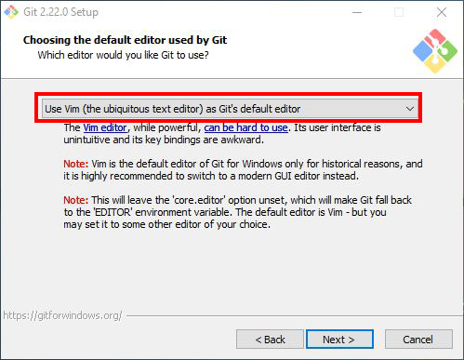

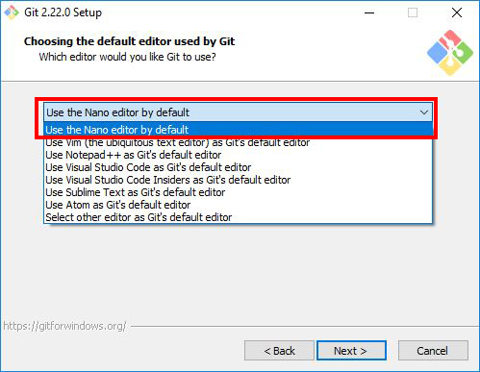

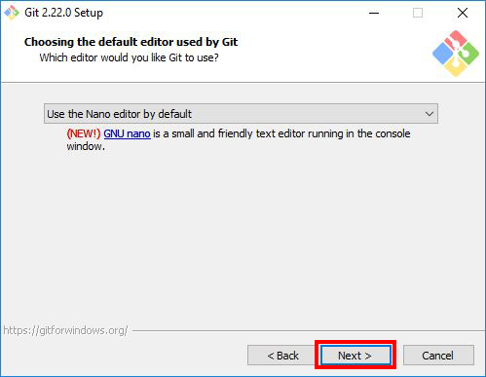

### Step 8: Adjust your PATH Environment

### Choose the option you want depending on where you want to use Git and click “Next”.

Select **“Use Git from Git Bash only”** option if want to run Git and Bash commands from Git Bash only. This means that you won’t be able to run Git commands such as git status on Windows Command Prompt or Powershell. They will only be found on Git Bash.

Select **“Git from the command line and also from 3rd-party software”** option if you want to run Git commands on Windows Command Prompt or Powershell.

**Notice:** Bash commands won’t work on Command Prompt or Powershell with this option, but only Git commands will work.

**Tip:** If you need run bash commands, you will have to open the Git Bash. So go ahead with this option if that is what you want.

Select **“Use Git and optional Unix tools from the Command Prompt”** option if you want to use both Git and Bash commands on Windows Command Prompt or Powershell. This option will override some default Windows Command Prompt tools like find and sort. I don’t use CMD or Powershell that much to worry about that. So I will go ahead with this option by clicking “Next”.

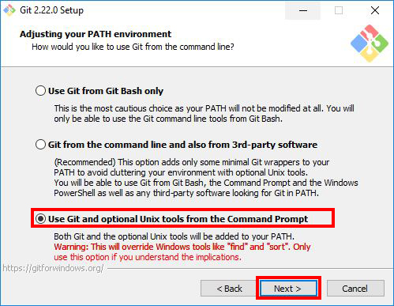

### Step 9: Choose HTTPS Transport Backend[Permalink](https://www.stanleyulili.com/git/how-to-install-git-bash-on-windows/#step-9-choose-https-transport-backend)

Next, select “Use the OpenSSL library” and click “Next”.

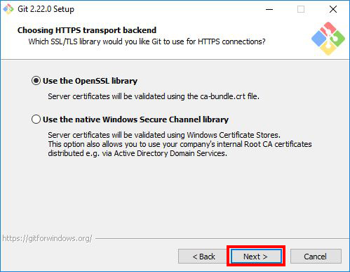

### Step 10: Configure the Line Ending Conversions

Select how Git should treat line endings in text files. It’s probably safe to go with the default option “Checkout Windows-Style, commit Unix-style line endings”. Click “Next” to proceed.

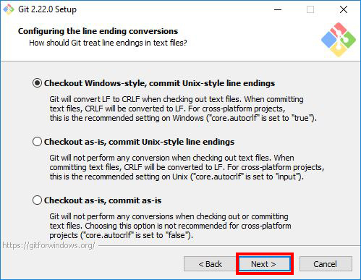

### Step 11: Configure the Terminal Emulator to use with Git Bsh[Permalink](https://www.stanleyulili.com/git/how-to-install-git-bash-on-windows/#step-11-configure-the-terminal-emulator-to-use-with-git-bsh)

Next, select the terminal emulator you want Git Bash to use. I will proceed with the default option “Use MinTTY(the default terminal of MSYS2) and click “Next”.

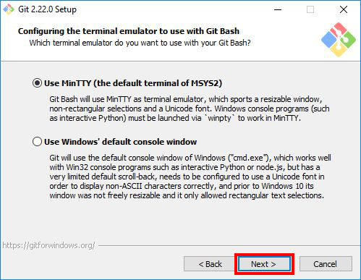

### Step 12: Configuring Extra Options

Select the features you want (the default options are fine) and click “Next”.

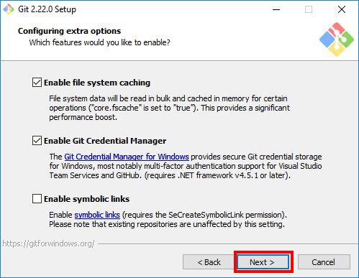

### Step 13: Configuring Extra Options

Enable experimental options if you want. Enabling them allows you to try out newer features that are still in development. I don’t enable this, so I will just proceed by clicking “Install” to start the installation process.

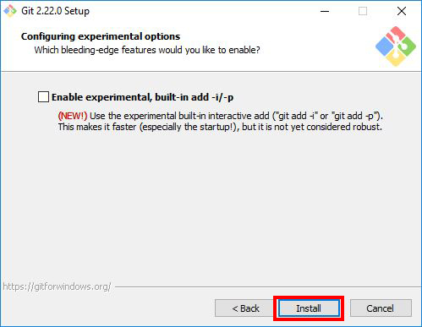

### Step 14: Wait for Installation

Now, wait for a few minutes as the Setup Wizard installs Git on your computer.

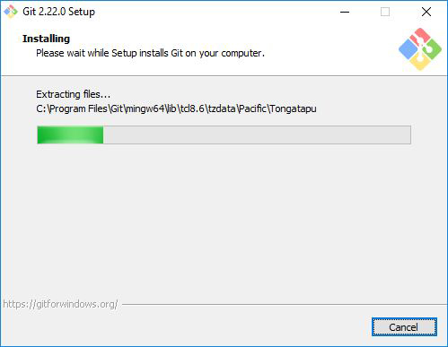

### Step 15: Complete the Git Setup Wizard

After the installation has finished, check the “Launch Git Bash” and click “Finish” launching Git Bash.

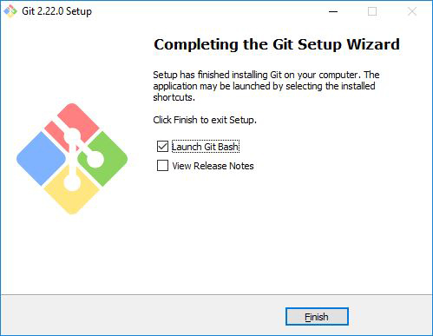

**Git –version**

Run this command in command prompt to know the git version and git is successfully installed or not.

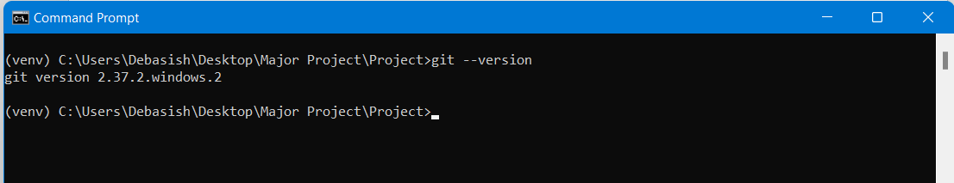

The Git Bash terminal will now open and you will be able to enter Git and Bash commands.

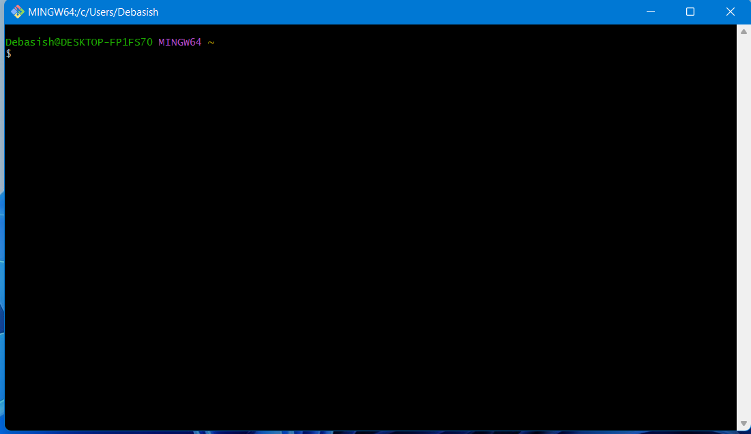Congratulations on successfully installing Git Bash.

**POSTMAN**

Postman is a platform for building and using APIs and helps for simplifying the steps in the APIs lifecycles to streamline collaboration for creating faster APIs. It includes various API tools to accelerate the development cycle, including the design mockups and testing documentation, etc. Postman will use it directly on a web browser or we can also download the desktop version also for convenient use.  Nowadays postman is also used by multinational companies like Twitter, Gear4music, BetterCloud, Momentive, etc. It also offers an API through which users can access data on the platform. It offers features such as search, notifications, alerts, security warnings, etc.

### Installing Postman on Windows

Follow the below steps to install Postman on Windows:

**Step 1**: Visit the <https://www.postman.com/> website using any web browser.

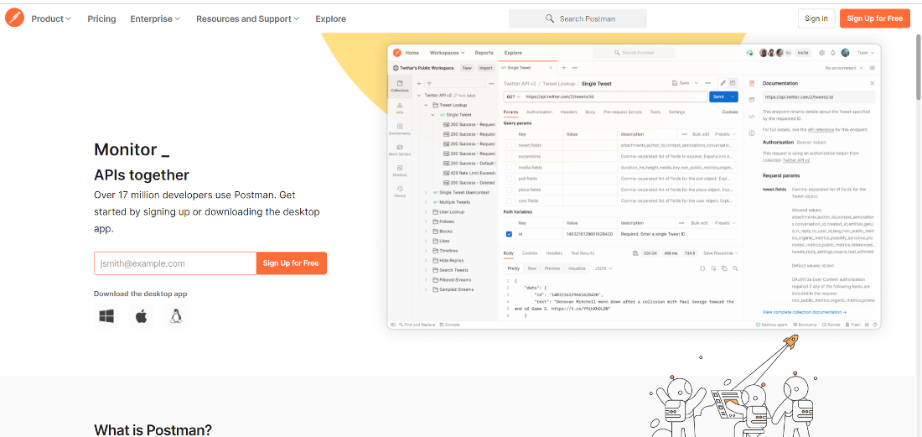

**Step 2**: Click on Windows Button to download.

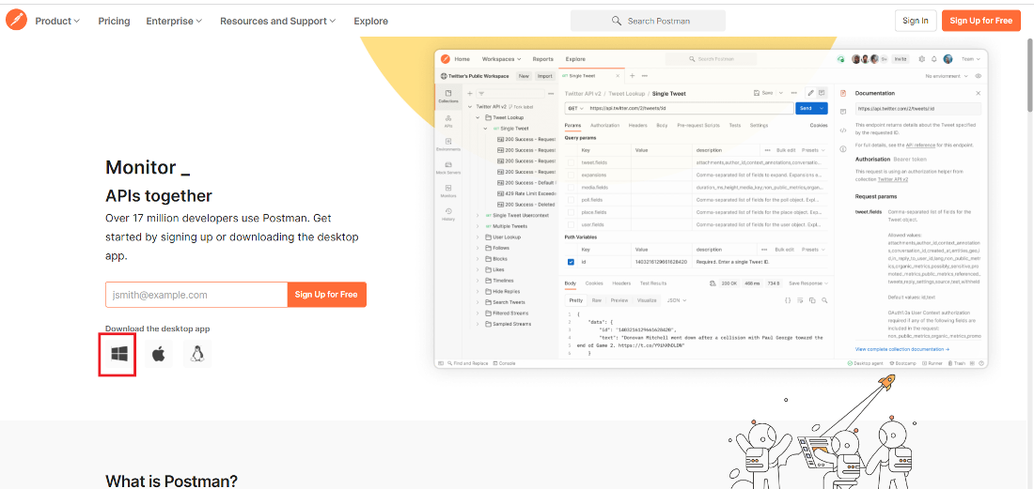

**Step 3**: Now click on Windows 64 – bit button.

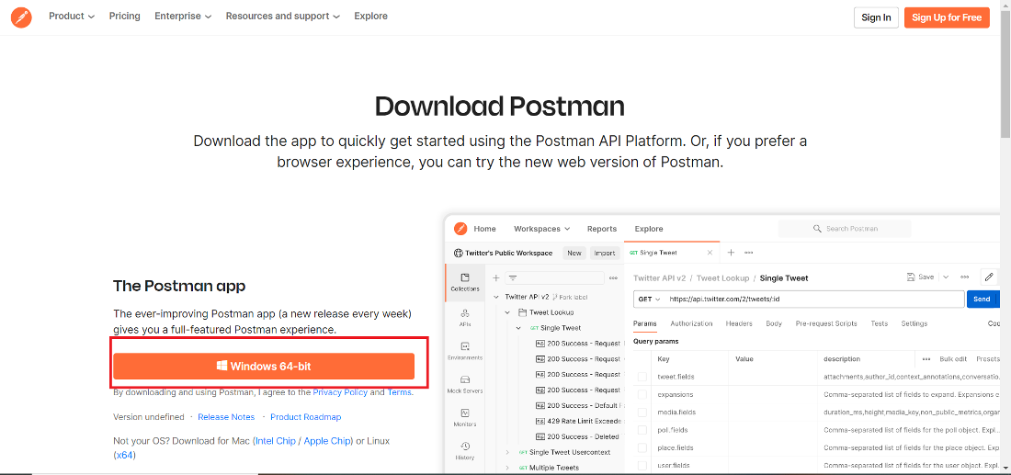

**Step 4**: Now check for the executable file in downloads in your system and run it.

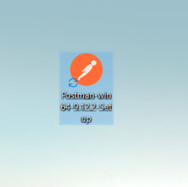

**Step 5**: Now installing process will start it takes a minute to install in the system.

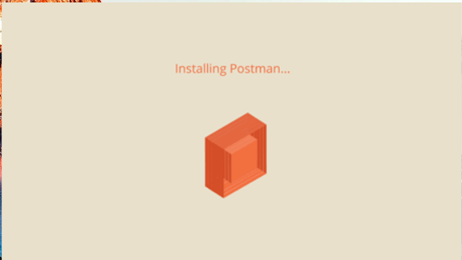

**Step 6:**After installing the program the software opens automatically. Now you can see the interface of the software.

**Step 6:**After installing the program the software opens automatically. Now you can see the interface of the software.

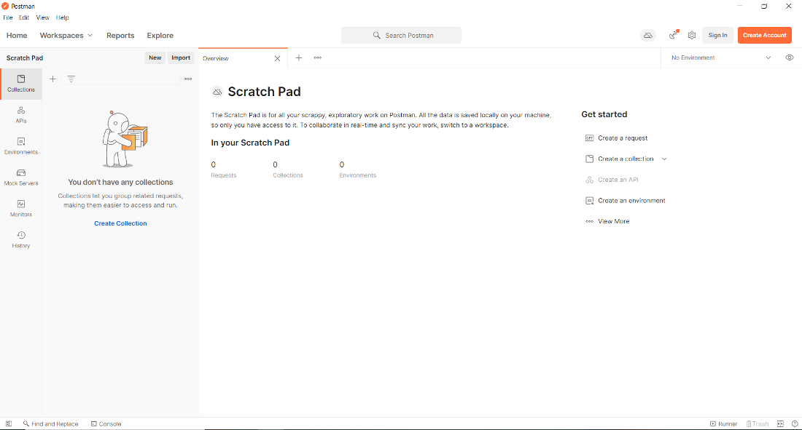

Postman is successfully installed on the system and an icon is created on the desktop.

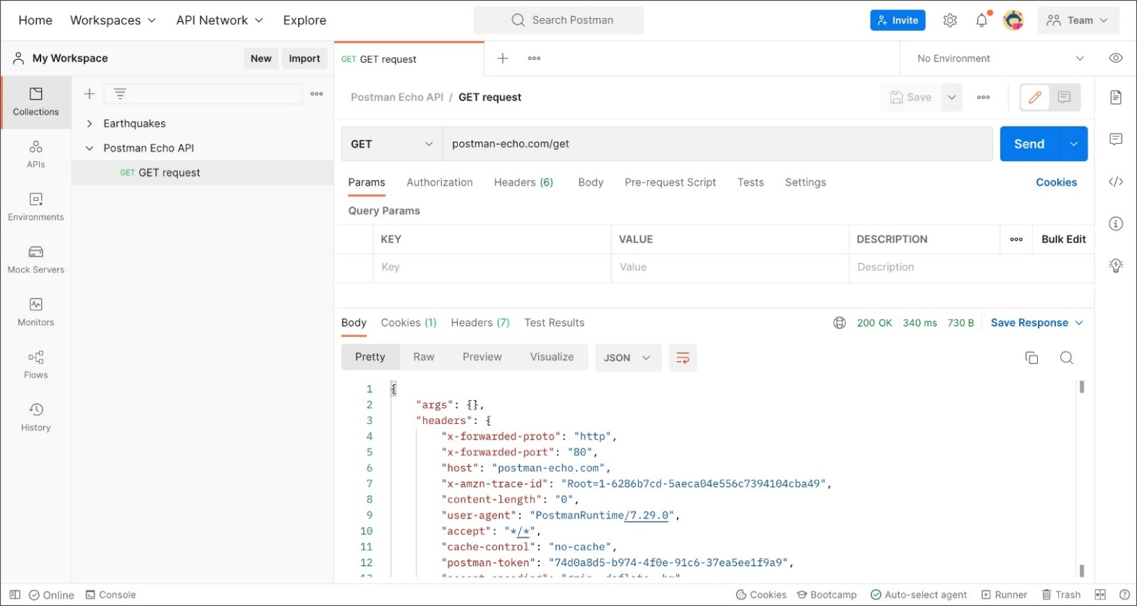

**Selected Software or Platform**

**What is Visual Studio Code?**

**Visual Studio Code** (famously known as **VS Code**) is a free open-source text editor by Microsoft. VS Code is available for Windows, Linux, and macOS. Although the editor is relatively lightweight, it includes some powerful features that have made VS Code one of the most popular development environment tools in recent times.

**Why we use Visual Studio Code.**

## Edit, build, and debug with ease

At its heart, Visual Studio Code features a lightning-fast source code editor, perfect for day-to-day use. With support for hundreds of languages, VS Code helps you be instantly productive with syntax highlighting, bracket-matching, auto-indentation, box-selection, snippets, and more. Intuitive keyboard shortcuts, easy customization and community-contributed keyboard shortcut mappings let you navigate your code with ease.

## Make it your own

Customize every feature to your liking and install any number of third-party extensions. While most scenarios work "out of the box" with no configuration, VS Code also grows with you, and we encourage you to optimize your experience to suit your unique needs. VS Code is an open-source project so you can also contribute to the growing and vibrant community on GitHub.

## Built with love for the Web

VS Code includes enriched built-in support for Node.js development with JavaScript and TypeScript, powered by the same underlying technologies that drive Visual Studio. VS Code also includes great tooling for web technologies such as JSX/React, HTML, CSS, SCSS, Less, and JSON.

## Robust and extensible architecture

Architecturally, Visual Studio Code combines the best of web, native, and language-specific technologies. Using Electron VS Code combines web technologies such as JavaScript and Node.js with the speed and flexibility of native apps. VS Code uses a newer, faster version of the same industrial-strength HTML-based editor that has powered the "Monaco" cloud editor, Internet Explorer's F12 Tools, and other projects. Additionally, VS Code uses a tools service architecture that enables it to integrate with many of the same technologies that power Visual Studio, including Roslyn for .NET, TypeScript, the Visual Studio debugging engine, and more.

Visual Studio Code includes a public extensibility model that lets developers build and use extensions, and richly customize their edit-build-debug experience.

**How to Developed a Project.**

In every Application Development or Project Development basically Follow Three basic step: -

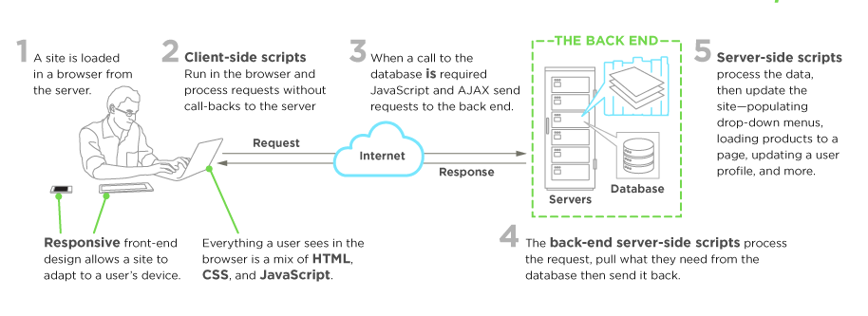

**Frontend Development**

**What is Front end Development?**

Everything you see on a website, like buttons, links, animations, and more, were created by a front-end web developer. It is the front-end developer's job to take the vision and design concept from the client and implement it through code.

## What Skills Do You Need to Become a Front-End Developer?

The three main languages you need to know well are HTML, CSS, and JavaScript. From there you can focus on frameworks, libraries, and other useful tools.

### HTML

HTML stands for Hypertext Markup Language. HTML displays the content on the page like buttons, links, headings, paragraphs, and lists.

### CSS

CSS stands for Cascading Style Sheets. CSS is responsible for the style of your web page including colors, layouts, and animations.

### JavaScript

JavaScript allows users to interact with the web page. Examples of JavaScript can be found in virtually any web page including the rimedu.com homepage.

For example, when I click on the Menu button at the top of the page, it will open a dropdown list of options. Every time I click on that button, it will toggle back and forth between opening and closing the Menu.

### SS Frameworks, Libraries, and Preprocessors

Once you learn the basics of CSS, then you can start to work with different frameworks and libraries. These tools were created as a way to help speed up the development process.

Frameworks like [Bootstrap](https://getbootstrap.com/) and [Tailwind CSS](https://tailwindcss.com/) allow you to add the catalog of classes to your webpage. As a result, you end up with professional and mobile-friendly designs.

There are dozens of options on the market and you don't need to learn them all. It's often helpful to look at jobs in your area and see what technologies they're using. Then you can focus on the most common/in-demand skills.

Here is a list of a few options:

* [Bootstrap](https://getbootstrap.com/)
* [Tailwind CSS](https://tailwindcss.com/)
* [Bulma](https://bulma.io/)
* [Materialize](https://materializecss.com/)
* [Semantic UI](https://semantic-ui.com/)

CSS pre-processors like [Sass](https://sass-lang.com/) and [Less](https://lesscss.org/), allow you to add logic and functionality to your CSS. These tools make your CSS clean and easy to work with.

### JavaScript libraries and frameworks

Just like with the CSS libraries and frameworks, there are many options for JavaScript.

It is not necessary to learn them all. Same as above, research job postings in your area to see what libraries and frameworks are being used.

Here are some popular options:

* [React](https://reactjs.org/)
* [Angular](https://angular.io/)
* [Vue](https://vuejs.org/)

These frameworks and libraries allow you to save time and do more with less code. It is possible to get a job specializing in React, Vue, or Angular.

**Frontend Technologies: -**

in our Team member Developed Front Part using some latest Technologies.

**What is HTML5?**

HTML stands for Hyper Text Markup Language. It is used to design web pages using a markup language. HTML is an abbreviation of Hypertext and Markup language. Hypertext defines the link between the web pages. The markup language is used to define the text document within the tag which defines the structure of web pages. HTML 5 is the fifth and current version of HTML. It has improved the markup available for documents and has introduced application programming interfaces (API) and Document Object Model(DOM).

**Features:**

* It has introduced new multimedia features which support audio and video controls by using <audio> and <video> tags.
* There are new graphics elements including vector graphics and tags.
* Enrich semantic content by including <header> <footer>, <article>, <section> and <figure> are added.
* Drag and Drop- The user can grab an object and drag it further dropping it to a new location.
* Geo-location services- It helps to locate the geographical location of a client.
* Web storage facility which provides web application methods to store data on the web browser.
* Uses SQL database to store data offline.
* Allows drawing various shapes like triangle, rectangle, circle, etc.
* Capable of handling incorrect syntax.
* Easy DOCTYPE declaration i.e., <!doctype html>
* Easy character encoding i.e., <meta charset=” UTF-8″>

**What is CSS?**

**C**ascading **S**tyle **S**heets, fondly referred to as CSS, is a simple design language intended to simplify the process of making web pages presentable.

CSS handles the look and feel part of a web page. Using CSS, you can control the colors of the text, the style of fonts, the spacing between paragraphs, how columns are sized and laid out, what background images or colors are used, layout designs, variations in display for different devices and screen sizes as well as a variety of other effects.

CSS is easy to learn and understand but it provides powerful control over the presentation of an HTML document. Most commonly, CSS is combined with the markup languages HTML or XHTML.

## Advantages of CSS

* **CSS saves time** − You can write CSS once and then reuse same sheet in multiple HTML pages. You can define a style for each HTML element and apply it to as many Web pages as you want.
* **Pages load faster** − If you are using CSS, you do not need to write HTML tag attributes every time. Just write one CSS rule of a tag and apply it to all the occurrences of that tag. So, less code means faster download times.
* **Easy maintenance** − To make a global change, simply change the style, and all elements in all the web pages will be updated automatically.
* **Superior styles to HTML** − CSS have a much wider array of attributes than HTML, so you can give a far better look to your HTML page in comparison to HTML attributes.
* **Multiple Device Compatibility** − Style sheets allow content to be optimized for more than one type of device. By using the same HTML document, different versions of a website can be presented for handheld devices such as PDAs and cell phones or for printing.
* **Global web standards** − Now HTML attributes are being deprecated and it is being recommended to use CSS. So it’s a good idea to start using CSS in all the HTML pages to make them compatible to future browsers.

## What is JavaScript?

JavaScript is a dynamic computer programming language. It is lightweight and most commonly used as a part of web pages, whose implementations allow client-side script to interact with the user and make dynamic pages. It is an interpreted programming language with object-oriented capabilities.

JavaScript was first known as **Live Script,** but Netscape changed its name to JavaScript, possibly because of the excitement being generated by Java. JavaScript made its first appearance in Netscape 2.0 in 1995 with the name **Live Script**. The general-purpose core of the language has been embedded in Netscape, Internet Explorer, and other web browsers.

* JavaScript is a lightweight, interpreted programming language.
* Designed for creating network-centric applications.
* Complementary to and integrated with Java.
* Complementary to and integrated with HTML.
* Open and cross-platform

## Client-Side JavaScript

Client-side JavaScript is the most common form of the language. The script should be included in or referenced by an HTML document for the code to be interpreted by the browser.

It means that a web page need not be a static HTML, but can include programs that interact with the user, control the browser, and dynamically create HTML content.

The JavaScript client-side mechanism provides many advantages over traditional CGI server-side scripts. For example, you might use JavaScript to check if the user has entered a valid e-mail address in a form field.

The JavaScript code is executed when the user submits the form, and only if all the entries are valid, they would be submitted to the Web Server.

JavaScript can be used to trap user-initiated events such as button clicks, link navigation, and other actions that the user initiates explicitly or implicitly.

## Advantages of JavaScript

The merits of using JavaScript are −

* **Less server interaction** − You can validate user input before sending the page off to the server. This saves server traffic, which means less load on your server.
* **Immediate feedback to the visitors** − They don't have to wait for a page reload to see if they have forgotten to enter something.
* **Increased interactivity** − You can create interfaces that react when the user hovers over them with a mouse or activates them via the keyboard.
* **Richer interfaces** − You can use JavaScript to include such items as drag-and-drop components and sliders to give a Rich Interface to your site visitors.

**Introduction to Angular**

Currently, application development using Web standard technology is done by hundreds of IT companies in India. So many projects are offshored to India by small- medium- and large-sized foreign companies. Indian IT companies use many frameworks for this purpose. Among them, Angular is the most popular one. So, job seekers in the web development field often ask the question: “What is Angular?” I, am Angular trainer, will give a comprehensive answer here for that question.

## What is Angular?

The name Angular derives simply from the fact that the HTML tags are enclosed by angle brackets. This blog is ready to give you an outline of Angular, which is a widespread and extensively benefited client-side framework.

Originally called AngularJS, Angular is Google’s JavaScript (TypeScript-based) open-source front-end web application framework. It is designed specifically for creating dynamic web applications. With this framework, you can develop front-end based applications without having to use other plug-ins or frameworks. Angular is used to develop state-of-the-art client-side applications, especially Single-Page applications. It has a series of features and tools that simplify the development of the applications themselves while simultaneously guaranteeing excellent performance results.

Angular is very similar to the [JavaScript](https://www.besanttechnologies.com/training-courses/web-designing-training/javascript-training-institute-in-chennai) framework as it is open-source. Angular was primarily familiarized by Google. A developer group from Google has developed this Angular framework, which is one of the top widespread modern frameworks. As there is great support from the **Angular CLI and Angular Apps** Google team and many ideas are being imported, Angular is said to be up to date. All the latest trends available in today’s market are incorporated with this wonderful framework.

You can use this framework to develop Single Page Applications. Pure JavaScript is used to write this Angular framework. Various platforms like mobile, web and desktop natives are supported by Angular. People who are fond of using Angular tools can also get the design patterns for building the assignments in a maintainable method. Usage of classes and methods becomes easier for you if using an Angular application that is properly crafted. A convenient code is structured enabling the users to reduce the time for learning what is going on.

<span style="display: inline-block; width: 0px; overflow: hidden; line-height: 0;" data-mce-type="bookmark" class="mce_SELRES_start">﻿</span><span style="display: inline-block; width: 0px; overflow: hidden; line-height: 0;" data-mce-type="bookmark" class="mce_SELRES_start">﻿</span>

## CHAPTER-2

**Hardware and Software Requirements**

*Contents:*

##### Introduction

* System environment
* Software requirement
* Hardware requirements

**Introduction:**

In this chapter, we mentioned the software and hardware requirements, which are necessary for successfully running this system. The major element in building systems is selecting compatible hardware and software. The system analyst has to determine what software package is best for the **“Lung Cancer Prediction System”** and, where software is not an issue, the kind of hardware and peripherals needed for the final conversion.

**System Environment:**

After analysis, some resources are required to convert the abstract system into the real one.

The hardware and software selection begins with requirement analysis, followed by a request for proposal and vendor evaluation.

Software and real system are identified. According to the provided functional specification all the technologies and its capacities are identified. Basic functions and procedures and methodologies are prepared to implement. Some of the Basic requirements such as hardware and software are described as follows: -

**Hardware and Software Specification**

**Software Requirements:**

* Technology: Python Django
* IDE : Pycharm/Atom
* Client Side Technologies: HTML, CSS, JavaScript , Bootstrap
* Server Side Technologies: Python
* Data Base Server: Sqlite
* Operating System: Microsoft Windows/Linux

**Hardware Requirements:**

* Processor: Pentium-III (or) Higher
* Ram: 64MB (or) Higher
* Hard disk: 80GB (or) Higher

## CHAPTER-3

**System Analysis**

*Contents:*

##### Purpose

* Project Scope
* Existing System
* Proposed System
* System Overview

### Purpose:

The purpose of the Lung Cancer Prediction System using EfficientNet is to provide a reliable and efficient system for predicting the possibility of lung cancer in patients using deep learning techniques. The system aims to assist doctors and healthcare professionals in making more accurate diagnoses, leading to earlier detection and treatment of lung cancer, which can significantly increase the chances of successful treatment outcomes. The system also aims to provide a user-friendly interface for patients to access their predicted results and past predictions. Overall, the purpose of this system is to improve the accuracy and speed of lung cancer diagnosis and treatment.

**Project Scope:**

The scope of Lung Cancer Prediction System using EfficientNet is significant as it can be used by healthcare professionals, researchers, and organizations in the field of cancer diagnosis and treatment. The system can assist doctors in making accurate predictions and diagnosis of lung cancer, which can ultimately lead to better treatment outcomes and improved patient care. Moreover, the system can be used to analyze large datasets of medical images to identify patterns and insights, which can be used for further research and development in the field of cancer treatment. This can lead to the development of more effective and efficient diagnostic and treatment methods, thereby contributing to the growth of the healthcare industry.

**Proposed System:**

The proposed system of Lung Cancer Prediction System using EfficientNet is a deep learning-based predictive model that utilizes medical imaging data to accurately predict the likelihood of a patient having lung cancer. The system is built using the EfficientNet architecture, which is known for its superior performance and efficiency in image classification tasks. The system takes input from CT scan images of the patient's lungs, preprocesses them, and feeds them into the EfficientNet model. The output of the model is the probability of the patient having lung cancer, which can be used by medical professionals to make informed decisions regarding the patient's diagnosis and treatment plan. The system also includes a user interface, allowing users to easily input their medical imaging data and receive a prediction. Additionally, the system includes modules for doctors and administrators, allowing them to manage patient data and view predictions made by the model.

**System Overview:**

Lung Cancer Prediction System divided in three main modules:

1. **Admin module**
2. **User module**
3. **Doctor module**

### **Admin Module details**

1. **Login**: The admin will have a unique username and password to access the admin panel.
2. **Dashboard**: This module will allow the admin to view the total number of users registered, total predictions made, and other related statistics.
3. **View Prediction Results**: The admin can view the predictions made by the users along with their details and prediction results.
4. **View Registered Users**: The admin can view the list of registered users along with their details.
5. **View Registered Doctors**: The admin can view the list of registered doctors along with their details.
6. **Change Password**: The admin can change their password using this module.
7. **Logout**: The admin can log out of the admin panel using this module.

### **User Module**

* **Signup**: A user can create a new account by providing basic details like name, email, and password.
* **Login**: The users can log in to their account using the registered email and password.
* **Prediction**: The users can upload their chest X-ray image and get the prediction result if the X-ray shows any indication of lung cancer or not.
* **View Prediction History**: The users can view their past prediction results in their profile.
* **View Doctors**: Based on the user's area/city, the system recommends doctors who specialize in treating lung cancer. This is done after the prediction, in case the system detects lung cancer in the user's chest X-ray.
* **Edit Profile**: Users can update their profile information like name, email, and contact details.
* **Change Password**: Users can change their login password for security purposes.
* **Logout**: Users can log out of the system once they have finished their session.

### **Doctor Module**

1. **Login**: Allows the doctor to log in to their account using their registered credentials.
2. **Dashboard**: Provides an overview of the doctor's account, including the total number of patients they have treated, the number of patients they have diagnosed with cancer, and the number of patients they have referred to a specialist.
3. **Patient History**: Allows the doctor to view the complete medical history of each patient they have treated. This includes previous diagnoses, lab results, and radiology reports.
4. **Profile Management**: Allows the doctor to manage their account details, including personal information, contact details, and login credentials.
5. **Logout**: Enables the doctor to log out of their account and end their session.

## CHAPTER-4

**Implementation issues**

**HTML -**

HTML (Hypertext Markup Language) is the standard markup language used to create web pages. It is a structured language that allows developers to define the structure of content on a webpage using tags, attributes, and elements. HTML provides a way for web browsers to interpret and display content in a structured and organized manner.

**CSS -**

CSS (Cascading Style Sheets) is a style sheet language used for describing the presentation of a document written in HTML. It enables developers to separate the structure of a webpage from its presentation. CSS allows developers to define the visual appearance of a webpage, such as font styles, colors, and layout.

**JavaScript -**

JavaScript is a high-level, interpreted programming language used to create interactive web pages. It is a client-side scripting language that allows developers to add dynamic elements and behavior to web pages. JavaScript can manipulate HTML and CSS in real-time, making web pages more responsive and engaging.

**Bootstrap -**

Bootstrap is a free and open-source CSS framework that is widely used to create responsive and mobile-first web pages. It provides pre-built CSS styles and JavaScript plugins that developers can use to create professional-looking web pages quickly and easily. Bootstrap is compatible with all modern web browsers and devices.

**Python -**

Python is a high-level, general-purpose programming language used to create a wide range of applications. It is a popular language for web development, scientific computing, data analysis, artificial intelligence, and many other areas. Python is known for its simplicity, readability, and easy-to-learn syntax.

**Django -**

Django is a free and open-source web framework written in Python. It follows the model-view-controller (MVC) architectural pattern and is designed to help developers build web applications quickly and easily. Django provides a number of built-in features, such as an object-relational mapper (ORM), automatic admin interface, and URL routing, that simplify web application development.

**Sqlite -**

SQLite is a lightweight, serverless, and self-contained relational database management system. It is widely used in web applications and mobile apps, as it requires minimal configuration and administration. SQLite is compatible with all major programming languages and provides a simple and efficient way to store and retrieve data.

**EfficientNet-**

EfficientNet is a highly efficient deep learning architecture designed for computer vision tasks, including medical image analysis. It optimizes both accuracy and computational efficiency by scaling the model's depth, width, and resolution. In the context of a lung cancer prediction system, EfficientNet can analyze medical images such as chest X-rays or CT scans to accurately predict cancerous or non-cancerous conditions. Its efficiency and effectiveness contribute to improved diagnostic accuracy and potentially earlier detection of lung cancer.

**CHAPTER-5**

## System Design

***Contents:***

* Use case diagram
* Class Diagram
* Sequence Diagram
* Data flow diagram

**Use Case Diagram:**

* Use case diagram consists of use cases and actors and shows the interaction between them. The key points are:
* The main purpose is to show the interaction between the use cases and the actor.
* To represent the system requirement from user’s perspective.
* The use cases are the functions that are to be performed in the module.

**Use Case Diagram Admin**

**Admin**

**Use Case Diagram – User**

**User**

**Use Case Diagram – Doctor**

**Doctor**

**DFD (Data Flow Diagram)**

**DFD Level 0**

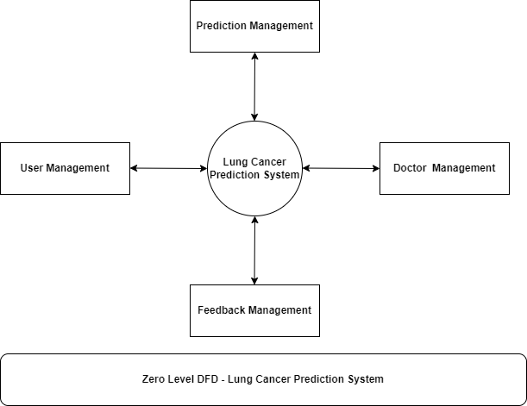

**DFD Level 1**

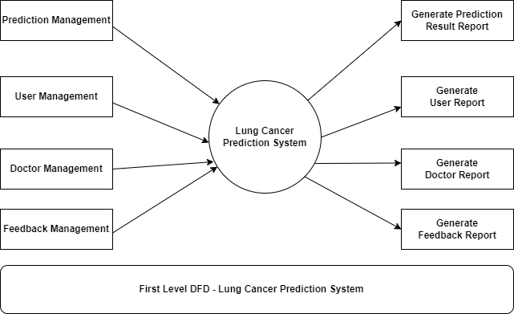

**ER DIAGRAM**

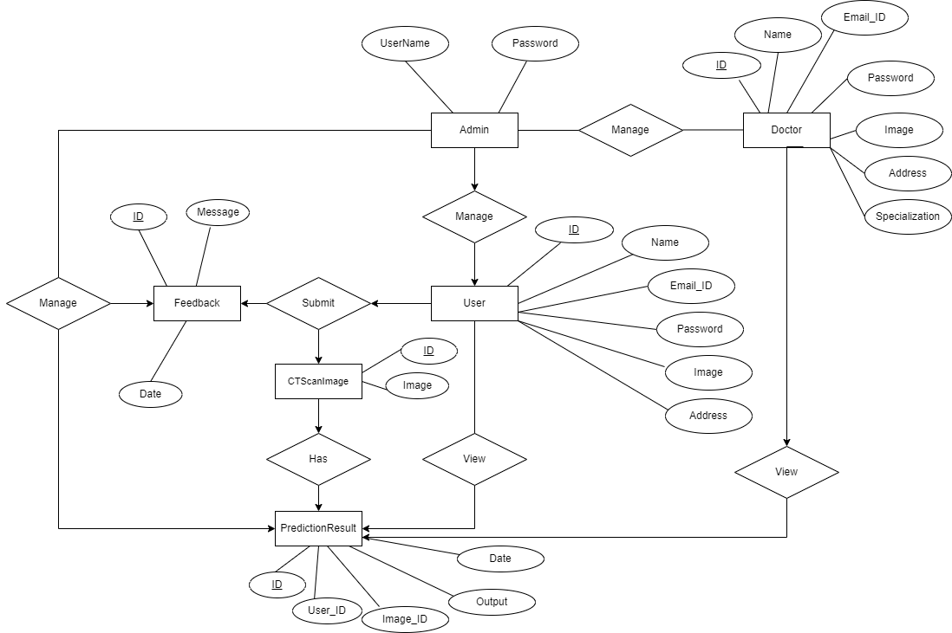

**Sequence Diagram For Administrator:-**

**Administrator**

**Success:hide()**

**Login**

**Application**

**Database**

**Login**

**:Request**

**:Validate()**

**:executeQuery()**

**Response**

**Show Result**

**Failed:show()**

Fig.5.4

**Sequence Diagram For User:-**

**User**

**Success:hide()**

**Login**

**Application**

**Database**

**Login**

**:Request**

**:Validate()**

**:executeQuery()**

**Response**

**Show Result**

**Failed:show()**

**CHAPTER-6**

**Output screens**

**HOME PAGE**

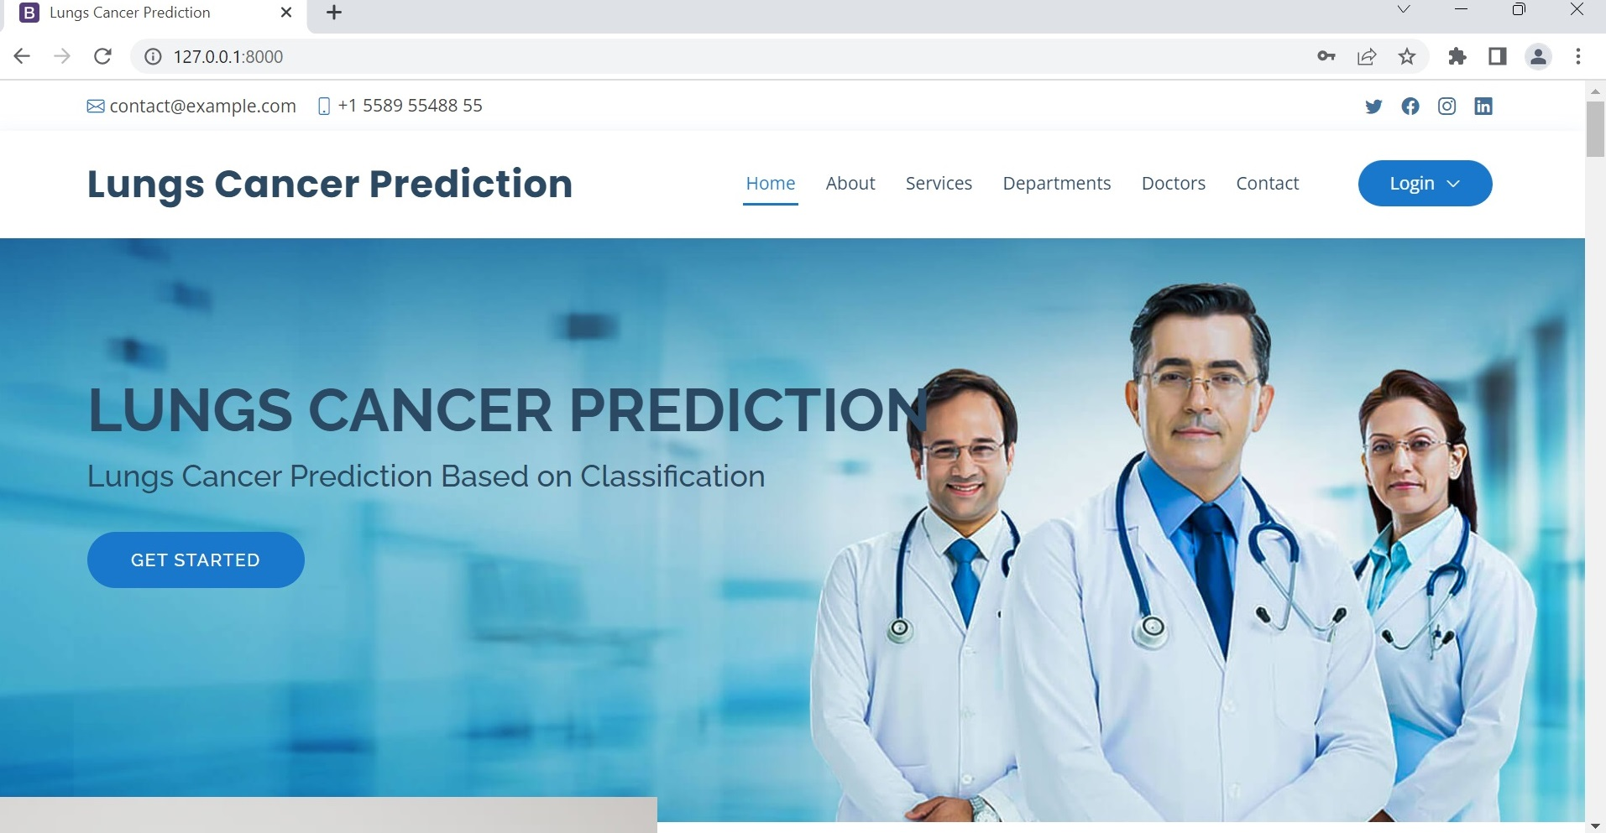

**USER REGISTRATION PAGE**

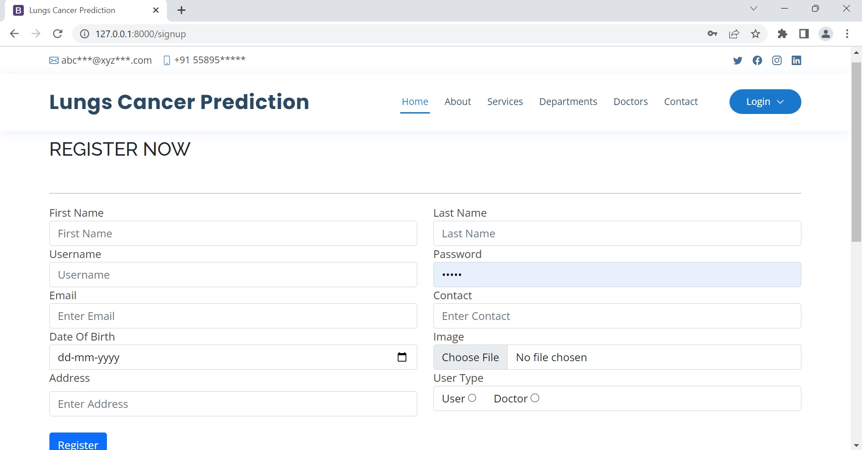

**USER LOGIN PAGE**

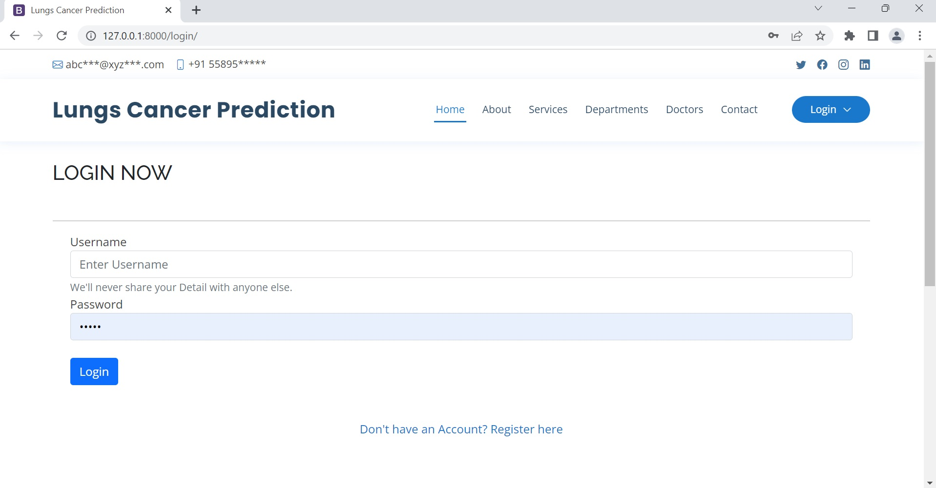

**USER HOME PAGE**

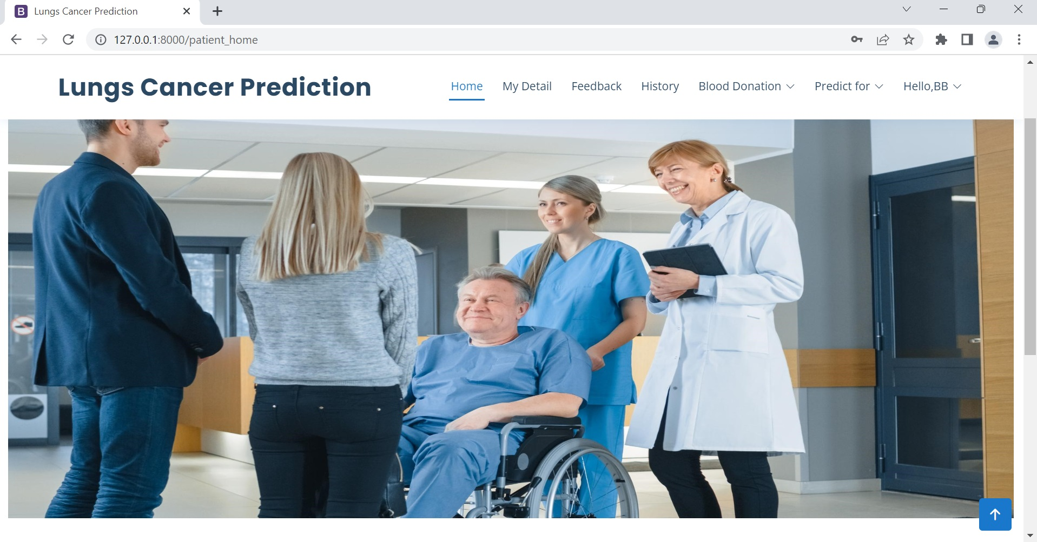

**PREDICTION PAGE**

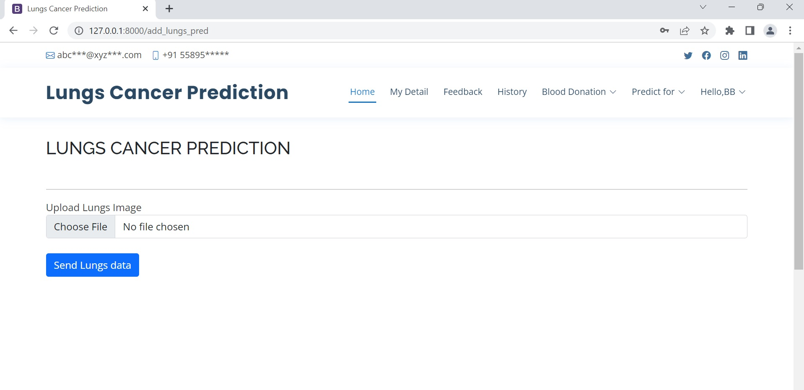

**VIEW PREDICTION RESULT HISTORY PAGE**

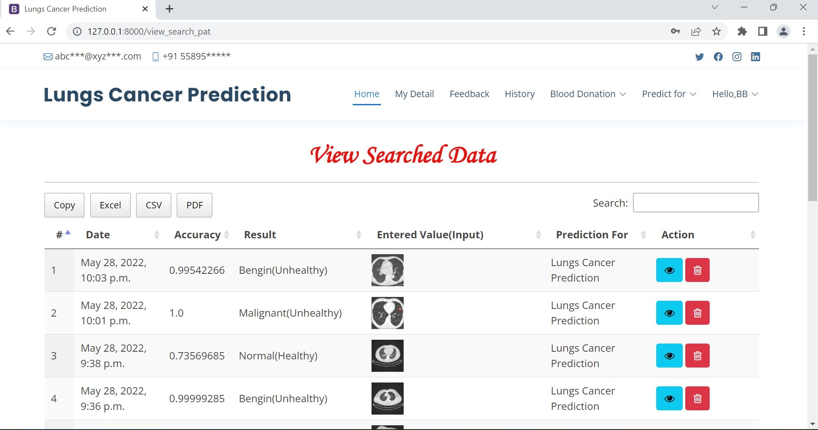

**SEND FEEDBACK PAGE**

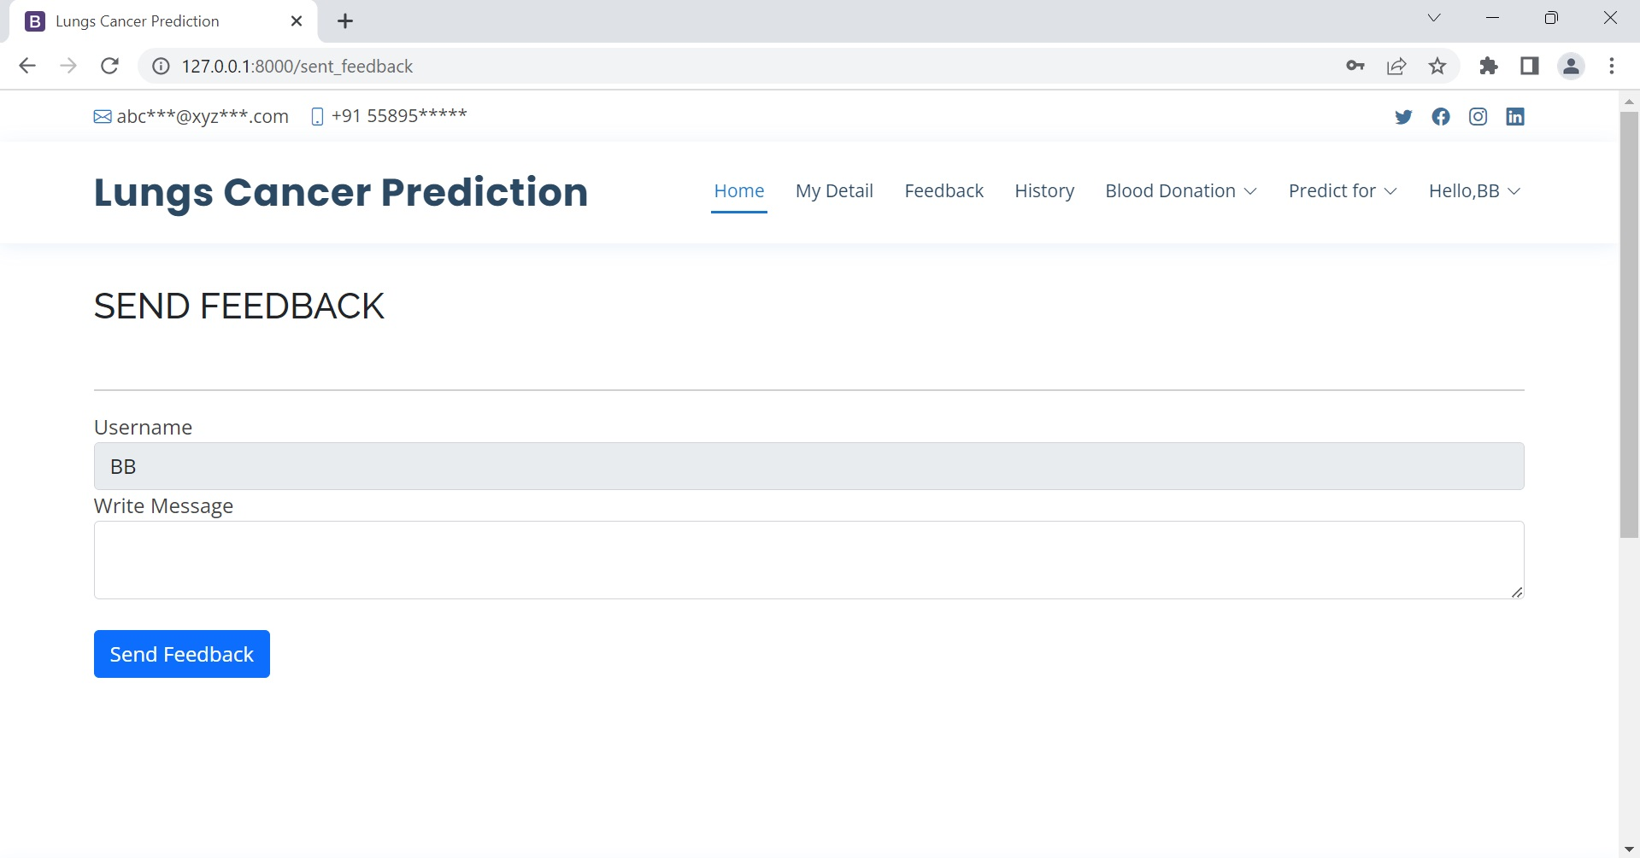

**EDIT PROFILE PAGE**

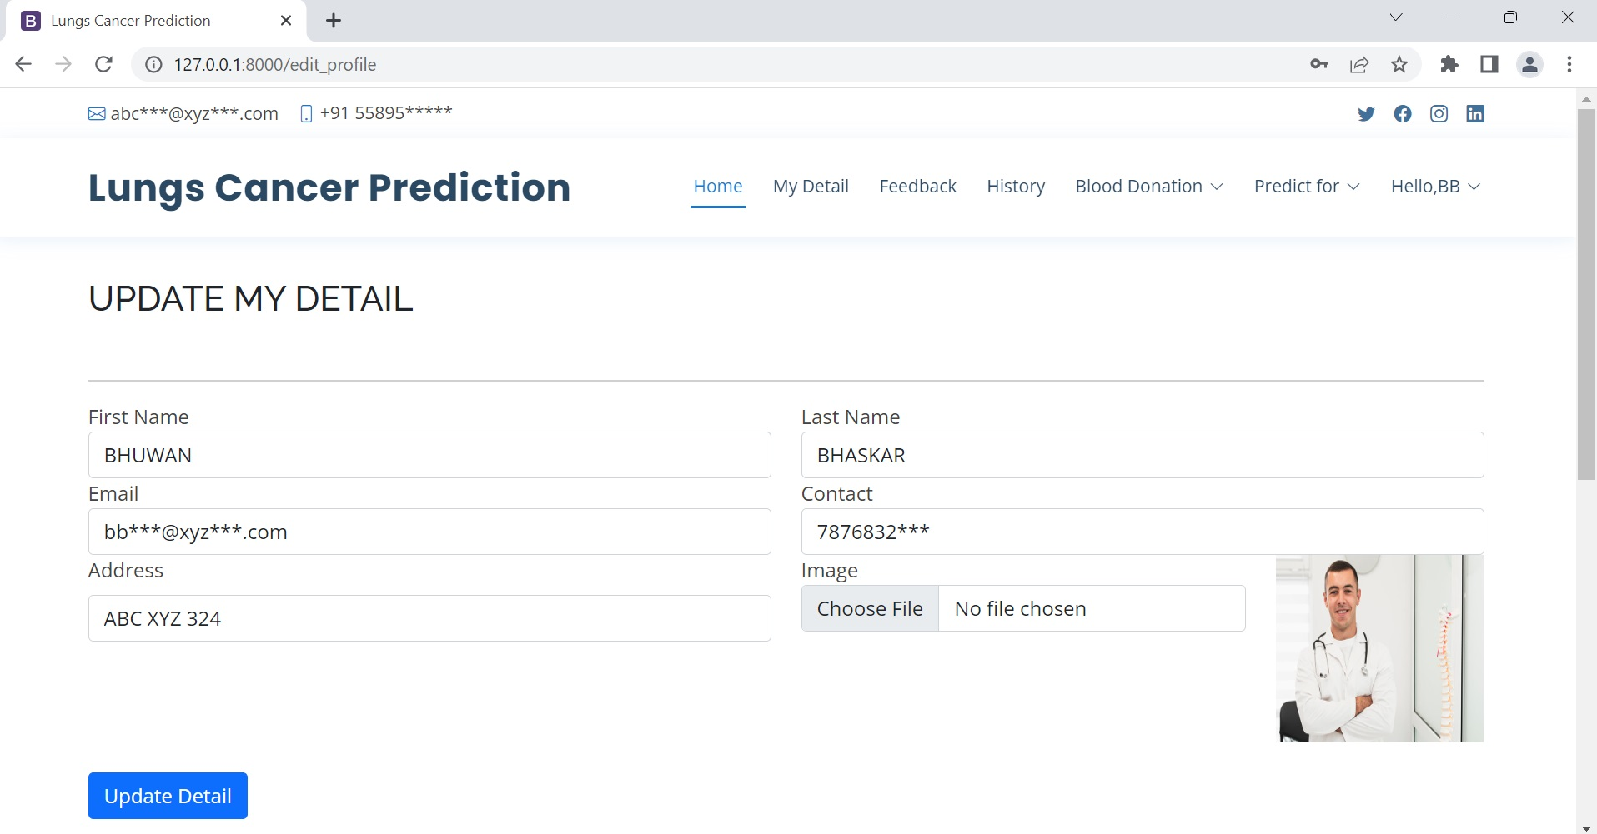

**CHANGE PASSWORD PAGE**

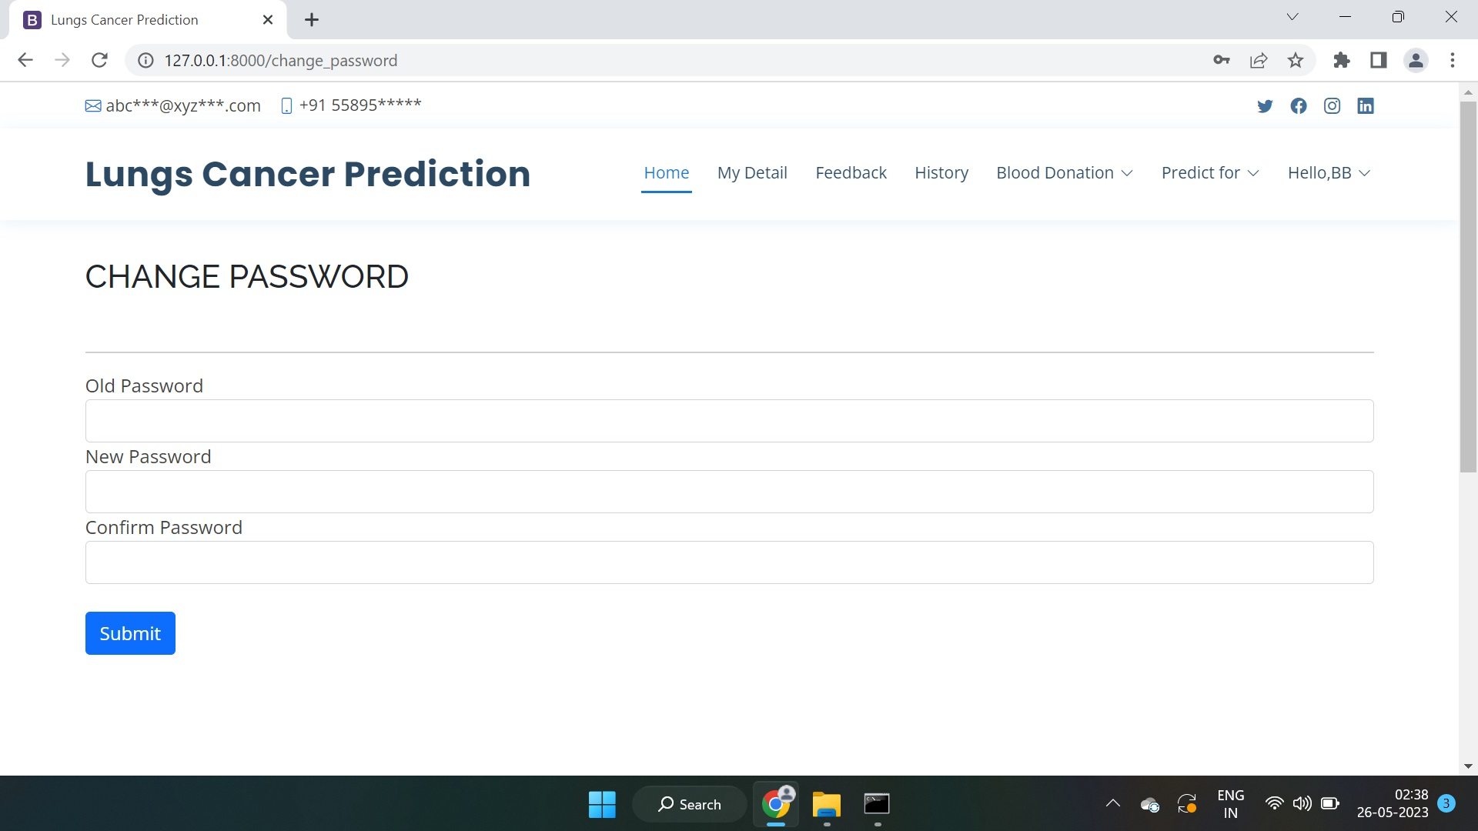

**ADMIN LOGIN PAGE**

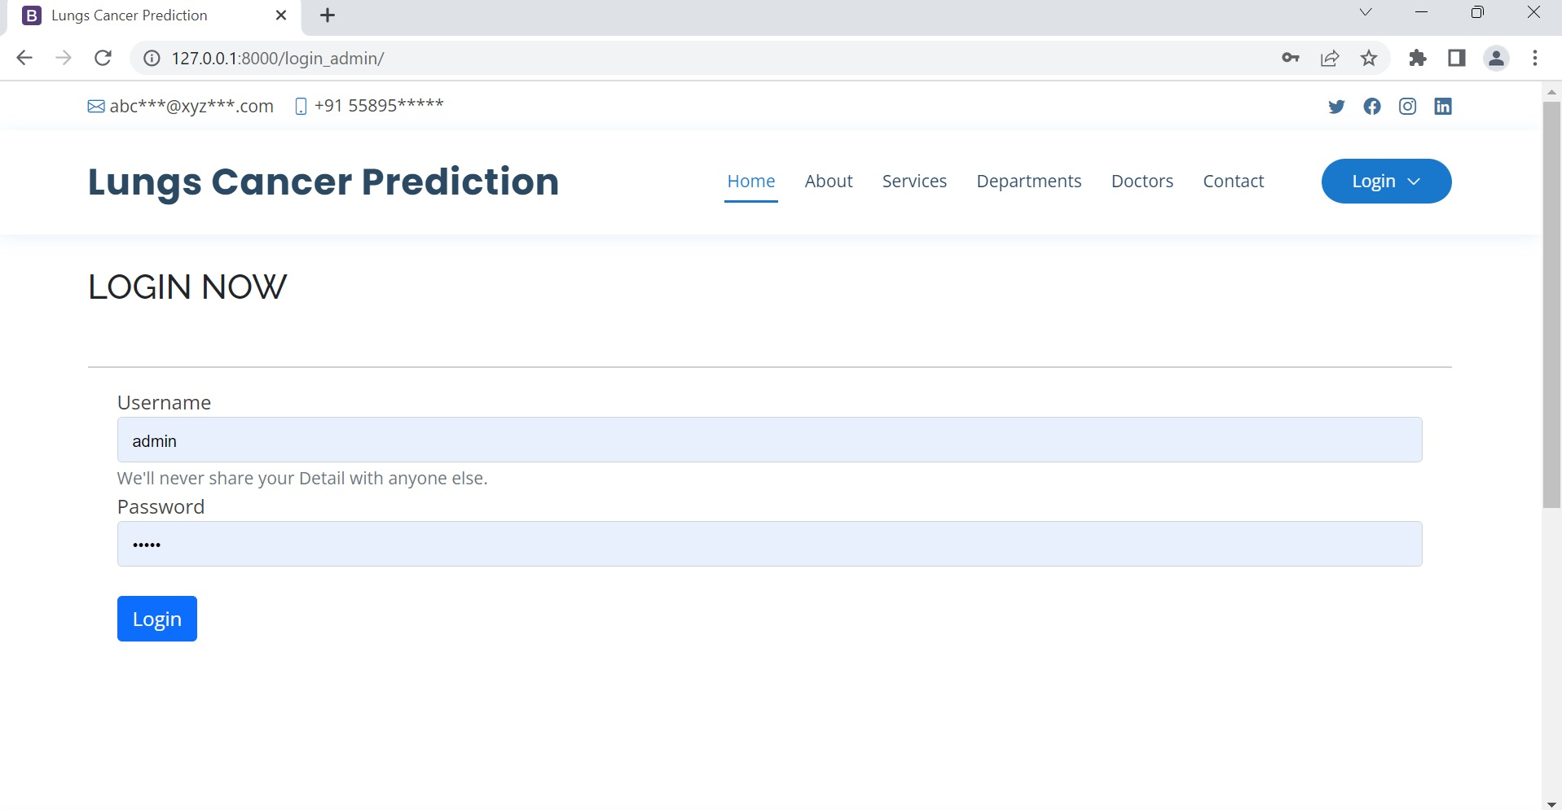

**ADMIN HOME PAGE**

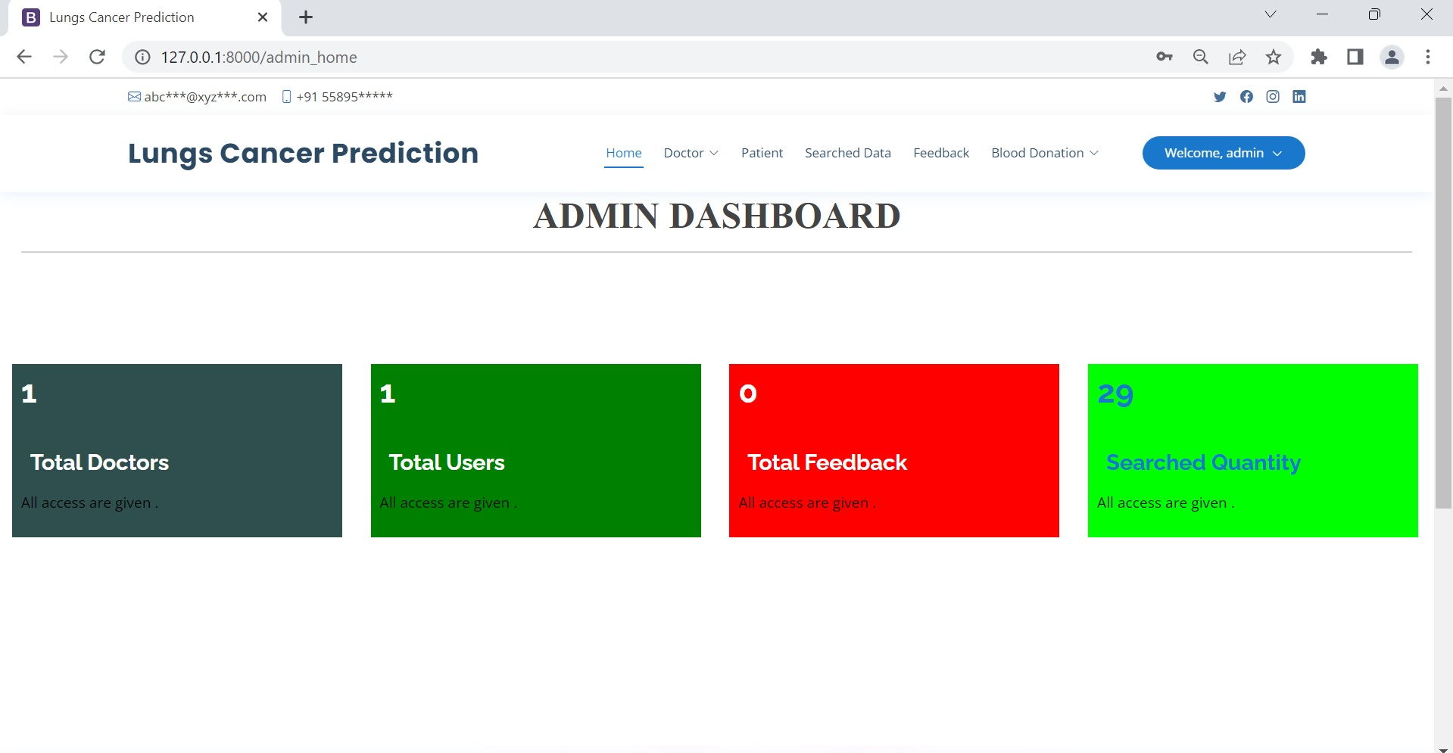

**ADD DOCTOR PAGE**

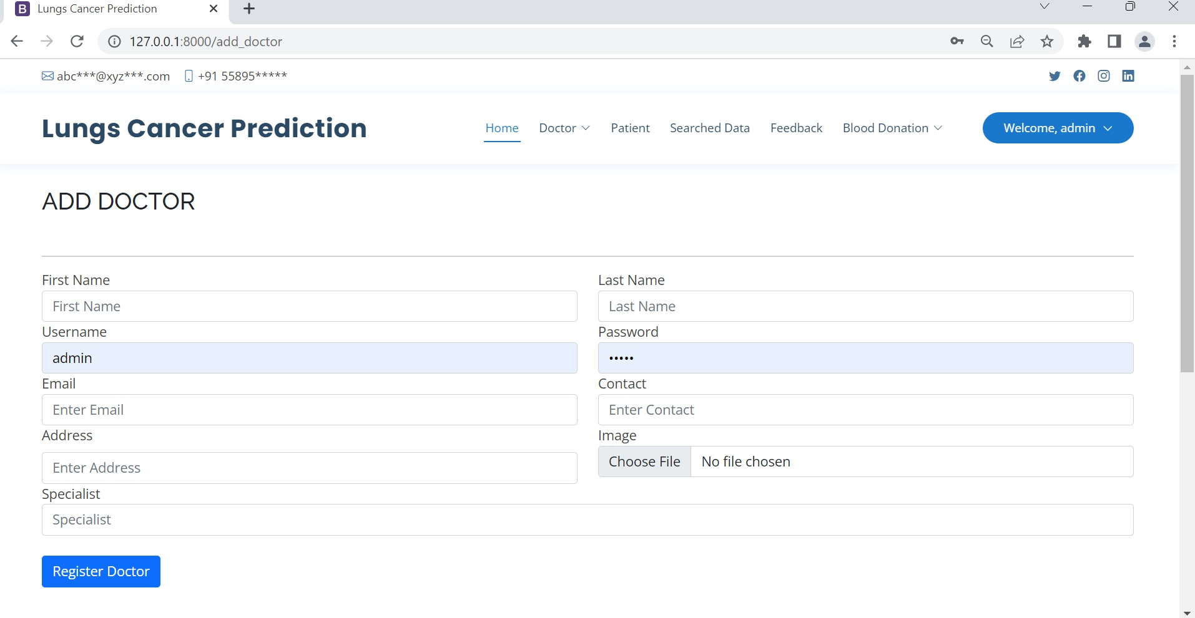

**MANAGE DOCTOR PAGE**

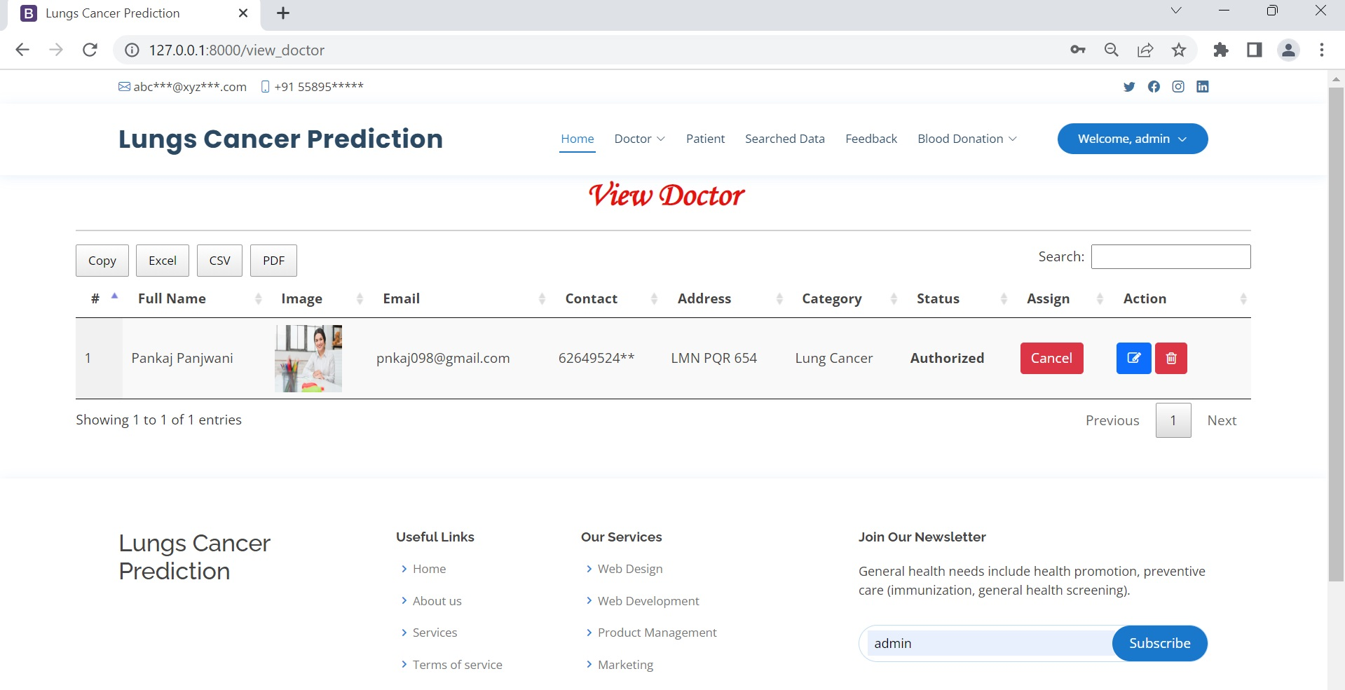

**VIEW ALL USERS PAGE**

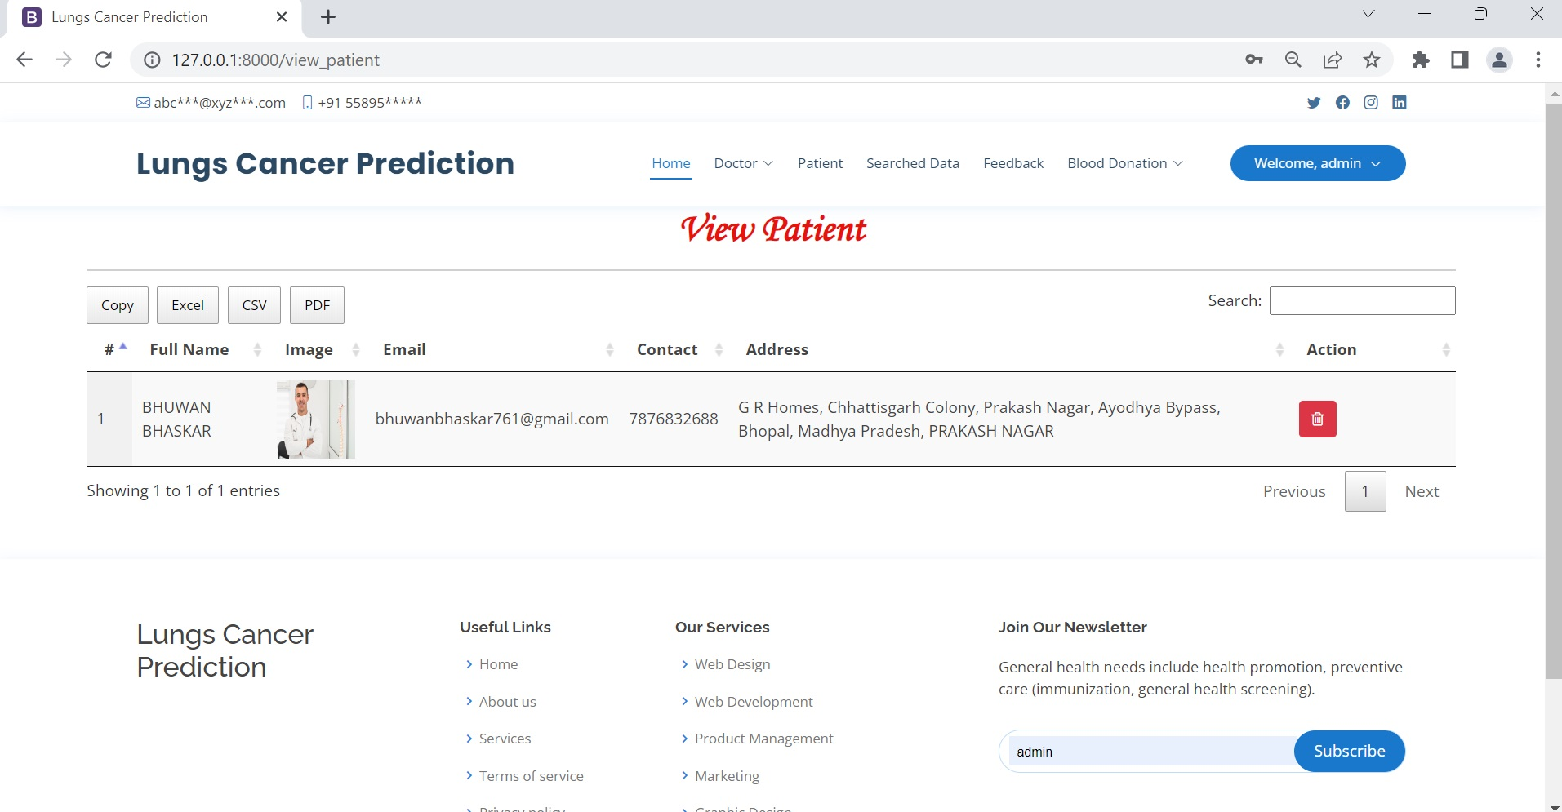

**VIEW ALL PREDICTION RESULT HISTORY PAGE**

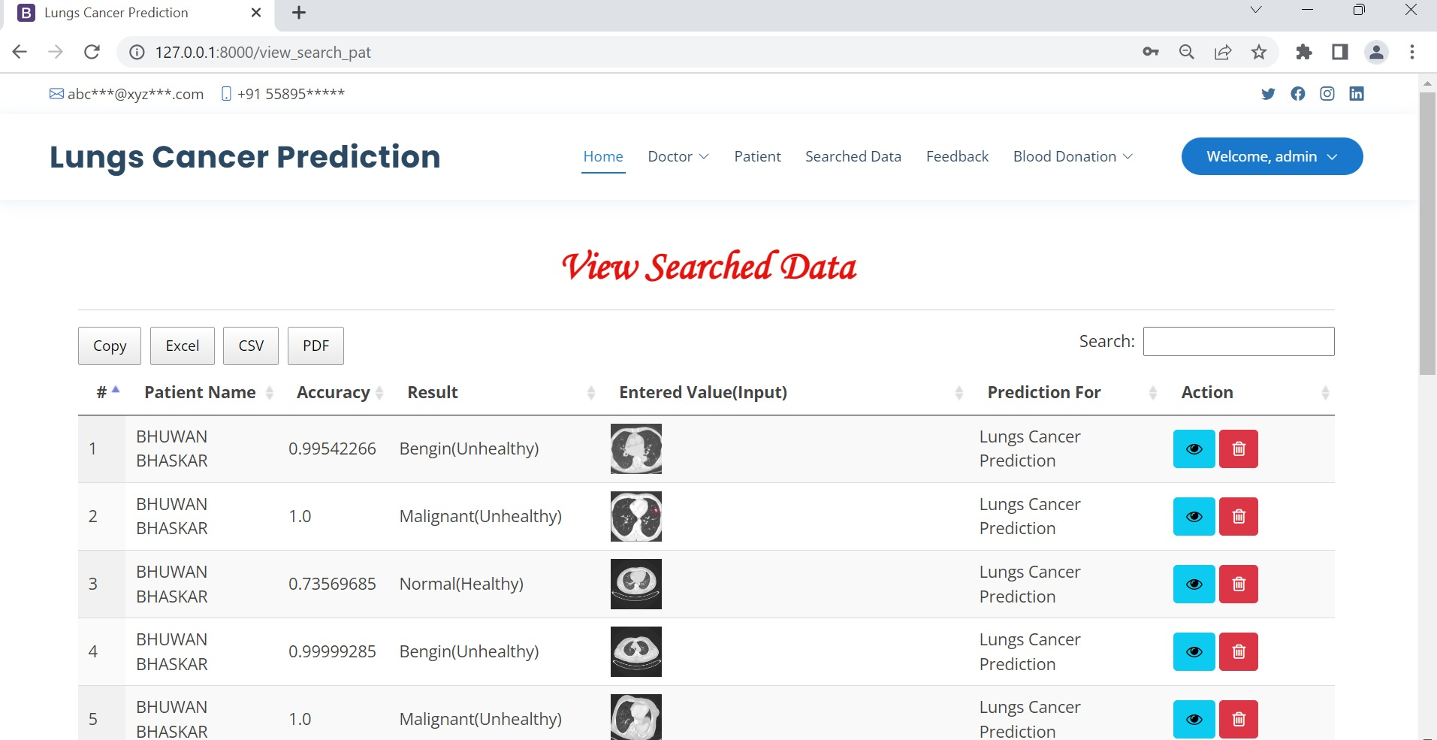

## CHAPTER-7

***Coding:***

**HOME PAGE CODING**

**<!DOCTYPE html>**

**<html lang="en">**

**{% load static %}**

**<head>**

**<meta charset="utf-8">**

**<meta content="width=device-width, initial-scale=1.0" name="viewport">**

**<title>Lungs Cancer Prediction</title>**

**<meta content="" name="description">**

**<meta content="" name="keywords">**

**<!-- Favicons -->**

**<link href="{% static 'img/favicon.png' %}" rel="icon">**

**<link href="{% static 'img/apple-touch-icon.png' %}" rel="apple-touch-icon">**

**<!-- Google Fonts -->**

**<link href="https://fonts.googleapis.com/css?family=Open+Sans:300,300i,400,400i,600,600i,700,700i|Raleway:300,300i,400,400i,500,500i,600,600i,700,700i|Poppins:300,300i,400,400i,500,500i,600,600i,700,700i" rel="stylesheet">**

**<!-- Vendor CSS Files -->**

**<link href="{% static 'vendor/fontawesome-free/css/all.min.css' %}" rel="stylesheet">**

**<link href="{% static 'vendor/animate.css/animate.min.css' %}" rel="stylesheet">**

**<link href="{% static 'vendor/bootstrap/css/bootstrap.min.css' %}" rel="stylesheet">**

**<link href="{% static 'vendor/bootstrap-icons/bootstrap-icons.css' %}" rel="stylesheet">**

**<link href="{% static 'vendor/boxicons/css/boxicons.min.css' %}" rel="stylesheet">**

**<link href="{% static 'vendor/glightbox/css/glightbox.min.css' %}" rel="stylesheet">**

**<link href="{% static 'vendor/remixicon/remixicon.css' %}" rel="stylesheet">**

**<link href="{% static 'vendor/swiper/swiper-bundle.min.css' %}" rel="stylesheet">**

**<!-- Template Main CSS File -->**

**<link href="{% static 'css/style.css' %}" rel="stylesheet">**

**<link rel="stylesheet" href="https://cdnjs.cloudflare.com/ajax/libs/font-awesome/4.7.0/css/font-awesome.min.css">**

**<!-- =======================================================**

**\* Template Name: Medilab - v4.7.1**

**\* Template URL: https://bootstrapmade.com/medilab-free-medical-bootstrap-theme/**

**\* Author: BootstrapMade.com**

**\* License: https://bootstrapmade.com/license/**

**======================================================== -->**

**<link rel='stylesheet' type='text/css' href="https://cdn.datatables.net/1.10.21/css/jquery.dataTables.min.css">**

**<link rel='stylesheet' type='text/css' href="https://cdn.datatables.net/buttons/1.6.2/css/buttons.dataTables.min.css">**

**<script src="https://code.jquery.com/jquery-3.5.1.js"></script>**

**<script src="https://cdn.datatables.net/1.10.21/js/jquery.dataTables.min.js"></script>**

**<script src="https://cdn.datatables.net/buttons/1.6.2/js/dataTables.buttons.min.js"></script>**

**<script src="https://cdnjs.cloudflare.com/ajax/libs/jszip/3.1.3/jszip.min.js"></script>**

**<script src="https://cdnjs.cloudflare.com/ajax/libs/pdfmake/0.1.53/pdfmake.min.js"></script>**

**<script src="https://cdnjs.cloudflare.com/ajax/libs/pdfmake/0.1.53/vfs_fonts.js"></script>**

**<script src="https://cdn.datatables.net/buttons/1.6.2/js/buttons.html5.min.js"></script>**

**<script>**

**$(document).ready(function() {**

**$('#example').DataTable( {**

**dom: 'Bfrtip',**

**buttons: [**

**'copyHtml5',**

**'excelHtml5',**

**'csvHtml5',**

**'pdfHtml5'**

**]**

**} );**

**} );**

**</script>**

**</head>**

**<body>**

**<!-- ======= Top Bar ======= -->**

**<div id="topbar" class="d-flex align-items-center fixed-top">**

**<div class="container d-flex justify-content-between">**

**<div class="contact-info d-flex align-items-center">**

**<i class="bi bi-envelope"></i> <a href="mailto:contact@example.com">contact@example.com</a>**

**<i class="bi bi-phone"></i> +1 5589 55488 55**

**</div>**

**<div class="d-none d-lg-flex social-links align-items-center">**

**<a href="#" class="twitter"><i class="bi bi-twitter"></i></a>**

**<a href="#" class="facebook"><i class="bi bi-facebook"></i></a>**

**<a href="#" class="instagram"><i class="bi bi-instagram"></i></a>**

**<a href="#" class="linkedin"><i class="bi bi-linkedin"></i></i></a>**

**</div>**

**</div>**

**</div>**

**<!-- ======= Header ======= -->**

**<header id="header" class="fixed-top">**

**<div class="container d-flex align-items-center">**

**<h1 class="logo me-auto"><a href="index.html">Lungs Cancer Prediction</a></h1>**

**{% if request.user.is_staff %}**

**<nav id="navbar" class="navbar order-last order-lg-0">**

**<ul>**

**<li><a class="nav-link scrollto active" href="{% url 'admin_home' %}">Home</a></li>**

**<li class="dropdown"><a href="#"><span>Doctor</span> <i class="bi bi-chevron-down"></i></a>**

**<ul>**

**<li><a href="/add_doctor">Add Doctor</a></li>**

**<li><a href="/view_doctor">View Doctor</a></li>**

**</ul>**

**</li>**

**<li><a class="nav-link scrollto" href="/view_patient">Patient</a></li>**

**<li><a class="nav-link scrollto" href="/view_search_pat">Searched Data</a></li>**

**<li><a class="nav-link scrollto" href="/view_feedback">Feedback</a></li>**

**<li class="dropdown"><a href="#"><span>Blood Donation</span> <i class="bi bi-chevron-down"></i></a>**

**<ul>**

**<li><a href="/request_blood">Request for Blood</a></li>**

**<li><a href="/donator_blood">Donate for Blood</a></li>**

**</ul>**

**</li>**

**<li class="dropdown">**

**<a href="#" class="appointment-btn scrollto" style="color: #fff;"><span class="d-none d-md-inline">Welcome,</span> {{request.user.username}} <i class="bi bi-chevron-down"></i></a>**

**<ul>**

**<li><a href="{% url 'change_password' %}">Password</a></li>**

**<li><a href="{% url 'logout' %}">Logout</a></li>**

**</ul>**

**</li>**

**</ul>**

**<i class="bi bi-list mobile-nav-toggle"></i>**

**</nav>**

**{% elif request.user.patient_set.all.0 %}**

**<nav id="navbar" class="navbar order-last order-lg-0">**

**<ul>**

**<li><a class="nav-link scrollto active" href="{% url 'patient_home' %}">Home</a></li>**

**<li><a class="nav-link scrollto" href="/profile_doctor">My Detail</a></li>**

**<li><a class="nav-link scrollto" href="/sent_feedback">Feedback</a></li>**

**<li><a class="nav-link scrollto" href="/view_search_pat">History</a></li>**

**<li class="dropdown"><a href="#"><span>Blood Donation</span> <i class="bi bi-chevron-down"></i></a>**

**<ul>**

**<li><a href="/search_blood">Search Blood</a></li>**

**<li><a href="/donate_blood">Donate Blood</a></li>**

**</ul>**

**</li>**

**<li class="dropdown"><a href="#"><span>Predict for</span> <i class="bi bi-chevron-down"></i></a>**

**<ul>**

**<li><a href="/add_lungs_pred">Lungs Cancer</a></li>**

**<li><a href="/add_heartdetail">Heart Prediction</a></li>**

**<li><a href="/add_genralhealth">General Health</a></li>**

**</ul>**

**</li>**

**<li class="dropdown"><a href="#"><span>Hello,{{request.user.username}}</span> <i class="bi bi-chevron-down"></i></a>**

**<ul>**

**<li><a href="{% url 'change_password' %}">Password</a></li>**

**<li><a href="{% url 'logout' %}">Logout</a></li>**

**</ul>**

**</li>**

**</ul>**

**<i class="bi bi-list mobile-nav-toggle"></i>**

**</nav>**

**{% elif request.user.doctor_set.all.0 %}**

**<nav id="navbar" class="navbar order-last order-lg-0">**

**<ul>**

**<li><a class="nav-link scrollto active" href="{% url 'doctor_home' %}">Home</a></li>**

**<li><a class="nav-link scrollto" href="/profile_doctor">My Detail</a></li>**

**<li><a class="nav-link scrollto" href="/view_search_pat">Searched Data</a></li>**

**<li><a class="nav-link scrollto" href="{% url 'change_password' %}">Password</a></li>**

**<li><a class="nav-link scrollto" href="{% url 'logout' %}">Logout</a></li>**

**{% comment %} <li class="dropdown"><a href="#"><span>Drop Down</span> <i class="bi bi-chevron-down"></i></a>**

**<ul>**

**<li><a href="#">Drop Down 1</a></li>**

**<li class="dropdown"><a href="#"><span>Deep Drop Down</span> <i class="bi bi-chevron-right"></i></a>**

**<ul>**

**<li><a href="#">Deep Drop Down 1</a></li>**

**<li><a href="#">Deep Drop Down 2</a></li>**

**<li><a href="#">Deep Drop Down 3</a></li>**

**<li><a href="#">Deep Drop Down 4</a></li>**

**<li><a href="#">Deep Drop Down 5</a></li>**

**</ul>**

**</li>**

**<li><a href="#">Drop Down 2</a></li>**

**<li><a href="#">Drop Down 3</a></li>**

**<li><a href="#">Drop Down 4</a></li>**

**</ul>**

**</li> {% endcomment %}**

**{% comment %} <li><a class="nav-link scrollto" href="#contact">Contact</a></li> {% endcomment %}**

**</ul>**

**<i class="bi bi-list mobile-nav-toggle"></i>**

**</nav>**

**{% else %}**

**<nav id="navbar" class="navbar order-last order-lg-0">**

**<ul>**

**<li><a class="nav-link scrollto active" href="/#hero">Home</a></li>**

**<li><a class="nav-link scrollto" href="/#about">About</a></li>**

**<li><a class="nav-link scrollto" href="/#services">Services</a></li>**

**<li><a class="nav-link scrollto" href="/#departments">Departments</a></li>**

**<li><a class="nav-link scrollto" href="/#doctors">Doctors</a></li>**

**{% comment %} <li class="dropdown"><a href="#"><span>Drop Down</span> <i class="bi bi-chevron-down"></i></a>**

**<ul>**

**<li><a href="#">Drop Down 1</a></li>**

**<li class="dropdown"><a href="#"><span>Deep Drop Down</span> <i class="bi bi-chevron-right"></i></a>**

**<ul>**

**<li><a href="#">Deep Drop Down 1</a></li>**

**<li><a href="#">Deep Drop Down 2</a></li>**

**<li><a href="#">Deep Drop Down 3</a></li>**

**<li><a href="#">Deep Drop Down 4</a></li>**

**<li><a href="#">Deep Drop Down 5</a></li>**

**</ul>**

**</li>**

**<li><a href="#">Drop Down 2</a></li>**

**<li><a href="#">Drop Down 3</a></li>**

**<li><a href="#">Drop Down 4</a></li>**

**</ul>**

**</li> {% endcomment %}**

**<li><a class="nav-link scrollto" href="#contact">Contact</a></li>**

**</ul>**

**<i class="bi bi-list mobile-nav-toggle"></i>**

**</nav>**

**<nav id="navbar" class="navbar order-last order-lg-0">**

**<ul>**

**<li class="dropdown">**

**<a href="#" class="appointment-btn scrollto" style="color: #fff;"><span class="d-none d-md-inline">Login</span> <i class="bi bi-chevron-down"></i></a>**

**<ul>**

**<li><a href="{% url 'login_admin' %}">Admin Login</a></li>**

**<li><a href="{% url 'login' %}">User Login</a></li>**

**</ul>**

**</li>**

**</ul>**

**</nav>**

**{% endif %}**

**</header><!-- End Header -->**

**<!-- ======= Hero Section ======= -->**

**<div class="mt-5 mb-5" style="margin-top:14%">**

**{% block body %}**

**{% endblock %}**

**</div>**

**<footer id="footer">**

**<div class="footer-top">**

**<div class="container">**

**<div class="row">**

**<div class="col-lg-3 col-md-6 footer-contact">**

**<h3>Lungs Cancer Prediction</h3>**

**<p>**

**YCT Academy Indrapuri <br>**

**Bhopal, MadhyaPradesh 462022<br>**

**India <br><br>**

**<strong>Phone:</strong> +1 5589 55488 55<br>**

**<strong>Email:</strong> info@example.com<br>**

**</p>**

**</div>**

**<div class="col-lg-2 col-md-6 footer-links">**

**<h4>Useful Links</h4>**

**<ul>**

**<li><i class="bx bx-chevron-right"></i> <a href="#">Home</a></li>**

**<li><i class="bx bx-chevron-right"></i> <a href="#">About us</a></li>**

**<li><i class="bx bx-chevron-right"></i> <a href="#">Services</a></li>**

**<li><i class="bx bx-chevron-right"></i> <a href="#">Terms of service</a></li>**

**<li><i class="bx bx-chevron-right"></i> <a href="#">Privacy policy</a></li>**

**</ul>**

**</div>**

**<div class="col-lg-3 col-md-6 footer-links">**

**<h4>Our Services</h4>**

**<ul>**

**<li><i class="bx bx-chevron-right"></i> <a href="#">Web Design</a></li>**

**<li><i class="bx bx-chevron-right"></i> <a href="#">Web Development</a></li>**

**<li><i class="bx bx-chevron-right"></i> <a href="#">Product Management</a></li>**

**<li><i class="bx bx-chevron-right"></i> <a href="#">Marketing</a></li>**

**<li><i class="bx bx-chevron-right"></i> <a href="#">Graphic Design</a></li>**

**</ul>**

**</div>**

**<div class="col-lg-4 col-md-6 footer-newsletter">**

**<h4>Join Our Newsletter</h4>**

**<p>General health needs include health promotion, preventive care (immunization, general health screening).</p>**

**<form action="" method="post">**

**<input type="email" name="email"><input type="submit" value="Subscribe">**

**</form>**

**</div>**

**</div>**

**</div>**

**</div>**

**<div class="container d-md-flex py-4">**

**<div class="me-md-auto text-center text-md-start">**

**<div class="copyright">**

**&copy; Copyright <strong><span>General Health Prediction</span></strong>. All Rights Reserved**

**</div>**

**<div class="credits">**

**<!-- All the links in the footer should remain intact. -->**

**<!-- You can delete the links only if you purchased the pro version. -->**

**<!-- Licensing information: https://bootstrapmade.com/license/ -->**

**<!-- Purchase the pro version with working PHP/AJAX contact form: https://bootstrapmade.com/medilab-free-medical-bootstrap-theme/ -->**

**</div>**

**</div>**

**<div class="social-links text-center text-md-right pt-3 pt-md-0">**

**<a href="#" class="twitter"><i class="bx bxl-twitter"></i></a>**

**<a href="#" class="facebook"><i class="bx bxl-facebook"></i></a>**

**<a href="#" class="instagram"><i class="bx bxl-instagram"></i></a>**

**<a href="#" class="google-plus"><i class="bx bxl-skype"></i></a>**

**<a href="#" class="linkedin"><i class="bx bxl-linkedin"></i></a>**

**</div>**

**</div>**

**</footer><!-- End Footer -->**

**<div id="preloader"></div>**

**<a href="#" class="back-to-top d-flex align-items-center justify-content-center"><i class="bi bi-arrow-up-short"></i></a>**

**<!-- Vendor JS Files -->**

**<script src="{% static 'vendor/purecounter/purecounter.js' %}"></script>**

**<script src="{% static 'vendor/bootstrap/js/bootstrap.bundle.min.js' %}"></script>**

**<script src="{% static 'vendor/glightbox/js/glightbox.min.js' %}"></script>**

**<script src="{% static 'vendor/swiper/swiper-bundle.min.js' %}"></script>**

**<script src="{% static 'vendor/php-email-form/validate.js' %}"></script>**

**<!-- Template Main JS File -->**

**<script src="{% static 'js/main.js' %}"></script>**

**</body>**

**</html>**

**REGISTRATION PAGE CODING**

**{% extends 'index.html' %}**

**{% load static %}**

**{% block body %}**

**<!-- register -->**

**{% if error == "create" %}**

**<script>**

**alert('Registration Successfull');**

**window.location="{% url 'login' %}";**

**</script>**

**{% endif %}**

**<section class="logins py-5">**

**<div class="container py-xl-5 py-lg-3">**

**<div class="title-section mb-md-5 mb-4">**

**<h6 class="w3ls-title-sub"></h6>**

**<h3 class="w3ls-title text-uppercase text-dark font-weight-bold">Register Now</h3>**

**</div><hr/>**

**<div class="login px-sm-12" style="width:100%">**

**<form action="" method="post" enctype="multipart/form-data">**

**{% csrf_token %}**

**<div class="form-group row">**

**<div class="col-md-6">**

**<label>First Name</label>**

**<input type="text" class="form-control" name="fname" placeholder="First Name" required="">**

**</div>**

**<div class="col-md-6">**

**<label>Last Name</label>**

**<input type="text" class="form-control" name="lname" placeholder="Last Name" required="">**

**</div>**

**</div>**

**<div class="form-group row">**

**<div class="col-md-6">**

**<label>Username</label>**

**<input type="text" class="form-control" name="uname" placeholder="Username" required="">**

**</div>**

**<div class="col-md-6">**

**<label>Password</label>**

**<input type="password" class="form-control" name="pwd" placeholder="Password" required="">**

**</div>**

**</div>**

**<div class="form-group row">**

**<div class="col-md-6">**

**<label>Email</label>**

**<input type="email" class="form-control" name="email" placeholder="Enter Email" required="">**

**</div>**

**<div class="col-md-6">**

**<label>Contact</label>**

**<input type="text" class="form-control" name="contact" placeholder="Enter Contact" required="">**

**</div>**

**</div>**

**<div class="form-group row">**

**<div class="col-md-6">**

**<label>Date Of Birth</label>**

**<input type="date" class="form-control" name="dob" placeholder="" required="">**

**</div>**

**<div class="col-md-6">**

**<label>Image</label>**

**<input type="file" class="form-control" name="image" required="">**

**</div>**

**</div>**

**<div class="form-group row">**

**<div class="col-md-6">**

**<label class="mb-2">Address</label>**

**<input type="text" class="form-control" name="add" id="password1" placeholder="Enter Address" required="">**

**</div>**

**<div class="col-md-6">**

**<label>User Type</label>**

**<div class="form-control">**

**User <input type="radio" placeholder="Patient" name="type" style="margin-right:4%" required="" value="Patient">**

**Doctor <input type="radio" placeholder="Patient" name="type" required="" value="Doctor">**

**</div>**

**</div>**

**</div>**

**<button type="submit" class="btn btn-primary submit mt-4">Register</button>**

**<p class="text-center mt-5">**

**<a href="#">By clicking Register, I agree to your terms</a>**

**</p></form>**

**</div></div></section><!-- //register -->**

**{% endblock %}**

**SIGN IN PAGE CODING:**

**{% extends 'index.html' %}**

**{% load static %}**

**{% block body %}**

**{% if error == "pat1" %}**

**<script>**

**alert('logged in successfully');**

**window.location="{% url 'patient_home' %}";**

**</script>**

**{% endif %}**

**{% if error == "notmember" %}**

**<script>**

**alert('Your information verification is pending.plz login after sometimes');**

**window.location="{% url 'logout' %}";**

**</script>**

**{% endif %}**

**{% if error == "pat2" %}**

**<script>**

**alert('logged in successfully');**

**window.location="{% url 'doctor_home' %}";**

**</script>**

**{% endif %}**

**{% if error == "not" %}**

**<script>**

**alert('Username & Password are not Matching');**

**</script>**

**{% endif %}**

**<!-- login -->**

**<section class="logins py-5">**

**<div class="container py-xl-5 py-lg-3">**

**<div class="title-section mb-md-5 mb-4">**

**<h6 class="w3ls-title-sub"></h6>**

**<h3 class="w3ls-title text-uppercase text-dark font-weight-bold">Login Now</h3>**

**</div><hr/>**

**<div class="login px-sm-4 mx-auto mw-100 login-wrapper">**

**<form class="login-wrapper" action="" method="post">**

**{% csrf_token %}**

**<div class="form-group">**

**<label>Username</label>**

**<input type="text" class="form-control" name="uname" placeholder="Enter Username" required="">**

**<small id="emailHelp" class="form-text text-muted">We'll never share your Detail with anyone else.</small>**

**</div>**

**<div class="form-group">**

**<label>Password</label>**

**<input type="password" class="form-control" name="pwd" placeholder="Enter Your Password" required="">**

**</div>**

**<button type="submit" class="btn btn-primary submit mt-4">Login</button>**

**<p class="text-center mt-5">**

**<a href="{% url 'signup' %}"> Don't have an Account? Register here</a>**

**</p>**

**</form>**

**</div>**

**</div>**

**</section>**

**<!-- //login -->**

**{% endblock %}**

**LUNG CANCER PREDICTION PAGE**

**{% extends 'index.html' %}**

**{% load static %}**

**{% block body %}**

**<!-- register -->**

**<section class="logins py-5">**

**<div class="container py-xl-5 py-lg-3">**

**<div class="title-section mb-md-5 mb-4">**

**<h6 class="w3ls-title-sub"></h6>**

**<h3 class="w3ls-title text-uppercase text-dark font-weight-bold">Lungs Cancer Prediction</h3>**

**</div><hr/>**

**<div class="login px-sm-12" style="width:100%">**

**<form action="" method="post" enctype="multipart/form-data">**

**{% csrf_token %}**

**<div class="form-group row">**

**<div class="col-md-12">**

**<label>Upload Lungs Image</label>**

**<input type="file" class="form-control" name="file" required="">**

**</div>**

**</div>**

**<button type="submit" class="btn btn-primary submit mt-4">Send Lungs data</button>**

**</form>**

**</div>**

**{% if data %}**

**<div class="container">**

**<div class="row">**

**<div class="col-6">**

**<h5>Input Image</h5>**

**<img src="{{data.uploaded.url}}" style="width:600px">**

**</div>**

**<div class="col-6">**

**<h5>Output Image</h5>**

**<img src="{{data.output.url}}" style="width:600px">**

**</div>**

**</div>**

**</div>**

**{% endif %}<br><br>**

**{% if clas_name == "Bengin" %}**

**<div class="container">**

**<div class="row">**

**<div class="col-12">**

**<h2 align="center" style="color:orange">You have a non – cancerous cells.</h2>**

**<p>Here are some of the precautions.</p>**

**<ul>**

**<li>Stop smoking immediately</li>**

**<li>Exercise regularly and maintain a balanced diet.</li>**

**<li>Avoid carcinogens at work</li>**

**</ul>**

**</div>**

**</div>**

**</div>**

**{% elif clas_name == "Normal" %}**

**<div class="container">**

**<div class="row">**

**<div class="col-12">**

**<h2 align="center" style="color:green">You are healthy.</h2>**

**</div>**

**</div>**

**</div>**

**{% elif clas_name == "Malignant" %}**

**<div class="container">**

**<div class="row">**

**<div class="col-12">**

**<h2 align="center" style="color:red">You have a cancerous cells. You may visit your nearby doctor and get treated immediately</h2>**

**</div>**

**</div>**

**</div>**

**{% endif %}**

**{% if data and clas_name != "Normal" %}**

**<div class="container-fluid">**

**<h1 align="center" style="font-weight:bold;font-family : 'Monotype Corsiva' ; color : #E6120E ;margin-top:4%">You can connect with our Doctors</h1>**

**</div><hr>**

**<table id="example" class="display" style="width:100%">**

**<thead>**

**<tr>**

**<th>#</th>**

**<th>Full Name</th>**

**<th>Image</th>**

**<th>Email</th>**

**<th>Contact</th>**

**<th>Address</th>**

**</tr>**

**</thead>**

**<tbody>**

**{% for i in doctor %}**

**<tr>**

**<td>{{forloop.counter}}</td>**

**<td>{{i.user.first_name}} {{i.user.last_name}}</td>**

**<td><img src="{{i.image.url}}" style="width:80px;height:80px"></td>**

**<td>{{i.user.email}}</td>**

**<td>{{i.contact}}</td>**

**<td>{{i.address}}</td>**

**</tr>**

**{% empty %}**

**<td colspan="6">There is no doctor available.</td>**

**{% endfor %}**

**</tbody>**

**</table>**

**</div>**

**{% endif %}**

**</div>**

**</section>**

**<!-- //register -->**

**{% endblock %}**

**VIEW PREDICTION HISTORY PAGE CODING**

**{% extends 'index.html' %}**

**{% load static %}**

**{% block body %}**

**<div class="container-fluid" style="width:90%;margin-top:12%">**

**<div class="container-fluid">**

**<h1 align="center" style="font-weight:bold;font-family : 'Monotype Corsiva' ; color : #E6120E ;margin-top:4%">View Prediction History</h1>**

**</div><hr>**

**<table id="example" class="display" style="width:100%">**

**<thead>**

**<tr>**

**<th>#</th>**

**{% if request.user.patient_set.all.0 %}**

**<th>Date</th>**

**{% else %}**

**<th>Patient Name</th>**

**{% endif %}**

**<th>Accuracy</th>**

**<th>Result</th>**

**<th>Entered Value(Input)</th>**

**<th>Prediction For</th>**

**<th>Action</th>**

**</tr>**

**</thead>**

**<tbody>**

**{% for i in data %}**

**<tr>**

**<td>{{forloop.counter}}</td>**

**{% if request.user.patient_set.all.0 %}**

**<td>{{i.created}}</td>**

**{% else %}**

**<td>{{i.patient.user.first_name}} {{i.patient.user.last_name}}</td>**

**{% endif %}**

**<td>{{i.prediction_accuracy}}</td>**

**<td>{% if i.result == "0" %}**

**<h5 style="color:green">Healthy</h5>**

**{% elif i.result == "1" %}**

**<h5 style="color:red">Unhealthy</h5>**

**{% elif i.result == 'Bengin' %}**

**{{i.result}}(Unhealthy)**

**{% elif i.result == 'Malignant' %}**

**{{i.result}}(Unhealthy)**

**{% elif i.result == 'Normal' %}**

**{{i.result}}(Healthy)**

**{% else %}**

**{{i.result}}**

**{% endif %}**

**</td>**

**<!-- <td>{{i.result}}</td>-->**

**<td>**

**{% if i.predict_for == "Lungs Cancer Prediction" %}**

**<img src="{{i.uploaded.url}}" style="width:50px;height:50px">**

**{% else %}**

**{{i.values_list}}**

**{% endif %}**

**</td>**

**<td>{{i.predict_for}}</td>**

**<td style="width:150px">**

**<a href="/detail_searched/{{i.id}}" ><button class="btn btn-info"><i class="fa fa-eye"></i></button></a>**

**<a href="/delete_searched/{{i.id}}" ><button class="btn btn-danger" onclick="return confirm('Are you sure?')"><i class="fa fa-trash-o"></i></button></a></td>**

**</tr>**

**{% endfor %}**

**</tbody>**

**</table>**

**</div>**

**{% endblock %}**

**EDIT PROFILE PAGE CODING**

**{% extends 'index.html' %}**

**{% load static %}**

**{% block body %}**

**<!-- register -->**

**{% if terror == "create" %}**

**<script>**

**alert('Detailed Updated Successfully');**

**window.location="{% url 'profile_doctor' %}";**

**</script>**

**{% endif %}**

**<section class="logins py-5">**

**<div class="container py-xl-5 py-lg-3">**

**<div class="title-section mb-md-5 mb-4">**

**<h6 class="w3ls-title-sub"></h6>**

**<h3 class="w3ls-title text-uppercase text-dark font-weight-bold">Update My Detail</h3>**

**</div><hr/>**

**<div class="login px-sm-12" style="width:100%">**

**<form action="" method="post" enctype="multipart/form-data">**

**{% csrf_token %}**

**<div class="form-group row">**

**<div class="col-md-6">**

**<label>First Name</label>**

**<input type="text" class="form-control" value="{{doc.user.first_name}}" name="fname" placeholder="First Name" required="">**

**</div>**

**<div class="col-md-6">**

**<label>Last Name</label>**

**<input type="text" class="form-control" value="{{doc.user.last_name}}" name="lname" placeholder="Last Name" required="">**

**</div>**

**</div>**

**<div class="form-group row">**

**<div class="col-md-6">**

**<label>Email</label>**

**<input type="email" class="form-control" value="{{doc.user.email}}" name="email" placeholder="Enter Email" required="">**

**</div>**

**<div class="col-md-6">**

**<label>Contact</label>**

**<input type="text" class="form-control" name="contact" value="{{doc.contact}}" placeholder="Enter Contact" required="">**

**</div>**

**</div>**

**{% if error != "pat" %}**

**<div class="form-group row">**

**<div class="col-md-12">**

**<label>Specialist</label>**

**<input name="type" class="form-control" value="{{doc.category}}">**

**</div>**

**</div>**

**{% endif %}**

**<div class="form-group row">**

**<div class="col-md-6">**

**<label class="mb-2">Address</label>**

**<input type="text" class="form-control" value="{{doc.address}}" name="add" id="password1" placeholder="Enter Address" required="">**

**</div>**

**<div class="col-md-4">**

**<label>Image</label>**

**<input type="file" class="form-control" name="image">**

**</div>**

**<div class="col-md-2">**

**<img src="{{doc.image.url}}" style="width:100%;height:150px">**

**</div>**

**</div>**

**<button type="submit" class="btn btn-primary submit mt-4">Update Detail</button>**

**</form>**

**</div>**

**</div>**

**</section>**

**<!-- //register -->**

**{% endblock %}**

**CHANGE PASSWORD PAGE CODING**

**{% extends 'index.html' %}**

**{% load static %}**

**{% block body %}**

**<!-- register -->**

**{% if terror == "yes" %}**

**<script>**

**alert('Password Changed.....');**

**window.location=('{% url 'logout' %}')**

**</script>**

**{% endif %}**

**{% if terror == "not" %}**

**<script>**

**alert('New Password and Confirm Password are not match');**

**</script>**

**{% endif %}**

**<section class="logins py-5">**

**<div class="container py-xl-5 py-lg-3">**

**<div class="title-section mb-md-5 mb-4">**

**<h6 class="w3ls-title-sub"></h6>**

**<h3 class="w3ls-title text-uppercase text-dark font-weight-bold">Change Password</h3>**

**</div><hr/>**

**<div class="login px-sm-12" style="width:100%">**

**<form action="" method="post" enctype="multipart/form-data">**

**{% csrf_token %}**

**<div class="form-group row">**

**<div class="col-md-12">**

**<label>Old Password</label>**

**<input type="password" class="form-control" name="pwd3" required="">**

**</div>**

**</div>**

**<div class="form-group row">**

**<div class="col-md-12">**

**<label>New Password</label>**

**<input type="password" class="form-control" name="pwd1" required="">**

**</div>**

**</div>**

**<div class="form-group row">**

**<div class="col-md-12">**

**<label>Confirm Password</label>**

**<input type="password" class="form-control" name="pwd2" required="">**

**</div>**

**</div>**

**<button type="submit" class="btn btn-primary submit mt-4">Register Disease</button>**

**</form>**

**</div>**

**</div>**

**</section>**

**<!-- //register ---**

**{% endblock %}**

**ADMIN LOGIN PAGE CODING**

**{% extends 'base.html' %}**

**{% load static %}**

**{% block body %}**

**<section class="section-services section-t8">**

**<div class="container">**

**<h3>Admin Sign In</h3><hr>**

**<div class="form">**

**<form class="form-a" action="" method="post" enctype="multipart/form-data">**

**{% csrf_token %}**

**<div class="row">**

**<div class="col-md-12 mb-2">**

**<div class="form-group">**

**<label class="pb-2" for="Type">Username</label>**

**<input type="text" class="form-control form-control-a" placeholder="Username" name="username">**

**</div>**

**</div>**

**<div class="col-md-12 mb-2">**

**<div class="form-group">**

**<label class="pb-2" for="Type">Password</label>**

**<input type="password" class="form-control form-control-a" placeholder="Password" name="password">**

**</div>**

**</div>**

**<div class="col-md-12">**

**<button type="submit" class="btn btn-b">Sign In</button>**

**</div></div></form></div></div>**

**{% include 'footer.html' %}**

**{% endblock %}**

**VIEW ALL REG. USERS PAGE CODING**

**{% extends 'index.html' %}**

**{% load static %}**

**{% block body %}**

**<div class="container-fluid" style="width:90%;margin-top:8%">**

**<div class="container-fluid">**

**<h1 align="center" style="font-weight:bold;font-family : 'Monotype Corsiva' ; color : #E6120E ;margin-top:4%">View Patient</h1>**

**</div><hr>**

**<table id="example" class="display" style="width:100%">**

**<thead>**

**<tr>**

**<th>#</th>**

**<th>Full Name</th>**

**<th>Image</th>**

**<th>Email</th>**

**<th>Contact</th>**

**<th>Address</th>**

**<th>Action</th>**

**</tr>**

**</thead>**

**<tbody>**

**{% for i in patient %}**

**<tr>**

**<td>{{forloop.counter}}</td>**

**<td>{{i.user.first_name}} {{i.user.last_name}}</td>**

**<td>{% if i.image %}<img src="{{i.image.url}}" style="width:80px;height:80px">{% endif %}</td>**

**<td>{{i.user.email}}</td>**

**<td>{{i.contact}}</td>**

**<td>{{i.address}}</td>**

**<td style="width:150px">**

**<a href="{% url 'delete_patient' i.id %}" ><button class="btn btn-danger" onclick="return confirm('Are you sure?')"><i class="fa fa-trash-o"></i></button></a></td>**

**</tr>**

**{% endfor %}**

**</tbody>**

**</table>**

**</div>**

**{% endblock %}**

**Testing**

Testing is an important aspect of any software system to ensure that it performs as expected and meets the required quality standards. The Lung Cancer Prediction System using EfficientNet can be tested in the following ways:

1. Unit testing: This involves testing individual components of the system such as the deep learning model, database queries, and API endpoints to ensure that they are functioning as expected.
2. Integration testing: This involves testing the interactions between different components of the system to ensure that they are integrated correctly and work together as expected.
3. User acceptance testing: This involves testing the system with real users to ensure that it meets their needs and expectations.
4. Performance testing: This involves testing the system's performance under different load conditions to ensure that it can handle the expected traffic and user load.
5. Security testing: This involves testing the system's security features to ensure that it is protected against common security threats such as SQL injection, cross-site scripting, and other vulnerabilities.
6. Regression testing: This involves testing the system after any changes or updates have been made to ensure that existing functionality has not been affected.

Overall, thorough testing of the Lung Cancer Prediction System using EfficientNet will help ensure that it is reliable, accurate, and effective in predicting lung cancer.

## CHAPTER-8

**Advantages & Limitations**

**Advantages of “Lung Cancer Prediction System”:**

The advantages of the Lung Cancer Prediction System using EfficientNet are:

1. Early detection: The system enables early detection of lung cancer by analyzing medical images, which can help in improving the chances of successful treatment.
2. Accuracy: The system uses deep learning algorithms, which provide a high level of accuracy in predicting the presence of cancer in medical images.
3. Speed: The use of EfficientNet architecture enables faster processing of medical images, which helps in reducing the time taken for diagnosis.
4. Cost-effective: The system reduces the need for human experts to analyze medical images, which can help in reducing the cost of diagnosis.
5. User-friendly: The system is designed to be user-friendly and easy to use, which helps in increasing its adoption among healthcare professionals.
6. Scalability: The system is scalable and can be easily integrated into existing healthcare systems, which makes it suitable for use in various healthcare settings.
7. Improved patient outcomes: By enabling early detection and accurate diagnosis, the system can help in improving patient outcomes and reducing the mortality rate associated with lung cancer.

**Limitations of “Lung Cancer Prediction System”:**

Some potential limitations of the Lung Cancer Prediction System using EfficientNet could include:

1. Accuracy: While deep learning models such as EfficientNet are capable of achieving high levels of accuracy, there is always a chance that the predictions may not be completely accurate due to the complexity and variability of cancer diagnoses.
2. Data Availability: The quality and quantity of data used to train the model can have a significant impact on the accuracy of the predictions. If the training data is not diverse enough or does not represent the target population, the model may not perform as well.
3. Ethical Considerations: Predictive models like this can raise ethical concerns related to data privacy, informed consent, and potential biases. It is important to carefully consider and address these issues to ensure the fair and ethical use of the system.
4. Technical Expertise: Developing and deploying deep learning models requires specialized technical expertise. Without the necessary skills and resources, it may be challenging to build and maintain a system like this.
5. Cost: The implementation and maintenance of a system like this can be costly, both in terms of time and resources. This may limit its accessibility to certain healthcare organizations or patients.

Top of FormCHAPTER-9

**Future Scope**

**FUTURE SCOPE:**

The future scope of Lung Cancer Prediction System using EfficientNet is quite promising. Some of the possible future directions of this project are:

1. Enhancing the accuracy of the model: The current model can be improved by incorporating more data and refining the training process to achieve better accuracy.
2. Extending the system for other types of cancer: The system can be extended to predict other types of cancer as well. This can be done by training the model on different types of cancer datasets.
3. Developing a mobile application: The system can be extended by developing a mobile application to make it more accessible to the users. This would allow users to use the system on-the-go.
4. Integrating Electronic Health Records (EHR): Integrating the system with Electronic Health Records (EHR) can provide doctors with more comprehensive patient data, which can further improve the accuracy of the model.
5. Enhancing the user interface: The system's user interface can be enhanced to make it more user-friendly and engaging for the users.
6. Collaborating with medical institutes: Collaborating with medical institutes can provide access to a larger dataset and more accurate medical records, which can lead to better model accuracy.
7. Developing a clinical decision support system: The system can be extended to become a clinical decision support system that can aid doctors in diagnosing lung cancer and other types of cancer.

**CONCLUSION**

Lung Cancer Prediction System using EfficientNet is an innovative and effective solution to predict lung cancer at an early stage. By implementing deep learning and machine learning techniques, this system can accurately detect and classify lung nodules from CT scan images. It can assist doctors and patients in making informed decisions regarding further diagnosis and treatment. The system is highly scalable, efficient, and cost-effective, making it accessible to a large population. Although there are some limitations, such as the need for high-quality CT scans and a trained model, the benefits of early detection and prevention of lung cancer outweigh them. Overall, the Lung Cancer Prediction System using EfficientNet has the potential to improve healthcare outcomes and save lives.

**BIBLIOGRAPHY**

* Wikipedia
* <https://panjwanitutorials.com/>
* <https://www.geeksforgeeks.org/python-django/>
* <https://www.javatpoint.com>
* <https://www.python.org/>
* <https://www.tutorialspoint/>

**REFERENCE BOOKS**

### Two scoops of Django for 1.11 by Daniel Greenfeld and Audrey Greenfield

### Lightweight Django by Elman and Mark Lavin